Contents
1. Data Flow Diagrams 3
1.1 Context Analysis Diagram 3
1.2 Spare Parts Processes 4
1.3 Operations 4
1.4 Create And Stock 5
1.5 Obsolescence 6
1.6 Finance 6
2. Application 7
3. Set Inventory Parameters Item Master 7
4. Jobcard 8
5. Spare Part System 8
5.1 Raw Material Development 8
5.2 Meaningful Product Conversion 9
5.3 Warehousing 10
5.4 Wholesale 11
5.5 Delivery To Customer 12
5.6 Issue To Customer 13
5.7 Material Repair and Operations 14
5.8 Customer Storage 15
6. Operations 16
6.1 Planning And Scheduling 16
6.2 Materials Management System 16
6.2.1 Appointment Setting 16
6.2.2 Materials Requisition 17
6.2.3 Issue Slip within Warehouse 18
6.2.4 Goods Receipt Note 19
6.2.5 Delivery Challan to Warehouse 19
6.2.6 Letter Of Credit 20
6.2.7 Recycled Materials 21
6.3 Shipment Management 22
6.4 Procurement 22
6.5 Bill Of Material 23
6.6 Bar coding 24
6.7 Stock Takes 24
6.8 Inventory Optimization 25
6.8.1 Forecasting 25
6.8.2 Events 25
6.8.3 Seasonality 26
6.8.3.1 Excessive Stock 26
6.8.3.2 Offload Slow-selling Inventory 27
6.8.3.3 Use Predictive Analysis Report 27
6.8.3.4 Offer Package Deals 27
6.8.3.5 Streamline Order Fulfillment 28
6.8.3.5.1 Returns 28
6.8.3.5.2 Picking 28
6.8.4 Stock Out 29
6.8.5 Holding Costs 30
6.8.6 Safety Stock 30
6.8.7 Lead Time 31
6.9 Store Room 31
6.10 Technical Management 31
6.10.1 Assets to be maintained 31
6.10.2 Assets Failed 32
7. Create And Stock 32
7.1 Stock Decision 32
7.1.1 Single Echelon 33
7.1.2 Multi Echelon 33
7.2 Spare Part Standardization 33
7.3 Capital Equipment 33
7.4 First Time Buy 34
7.5 Critical Spare Parts 35
8. Obsolescence And Disposal 35
8.1 End Of Life 35
8.2 Last time buy 36
8.3 Spare Part Disposal 37

- Data Flow Diagrams

  - Context Analysis Diagram

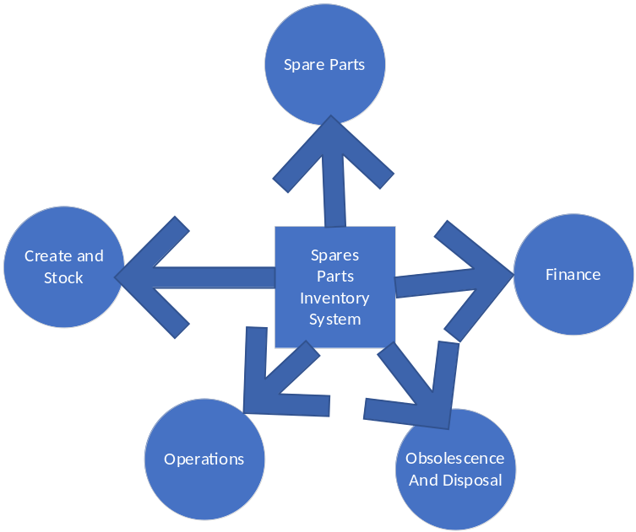

  - Spare Parts Processes

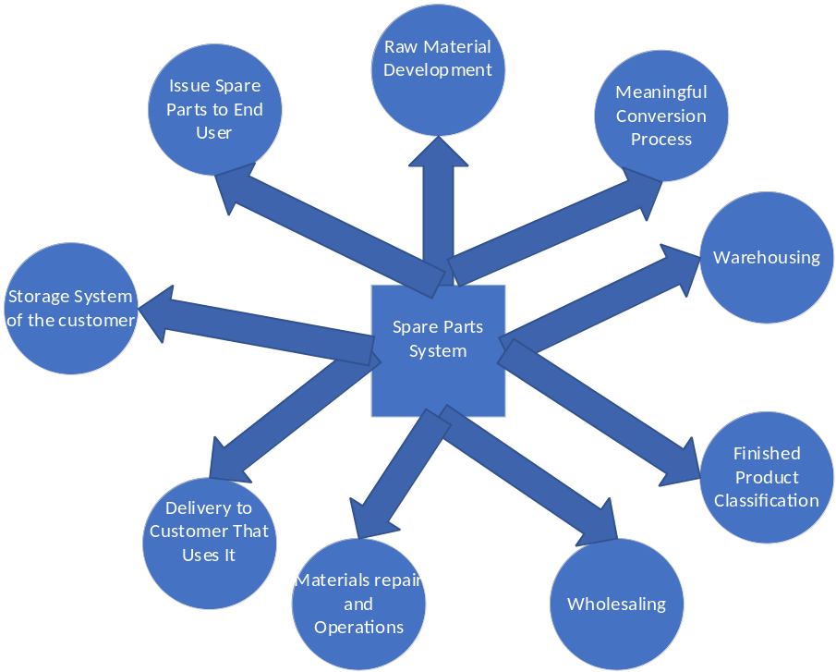

  - Operations
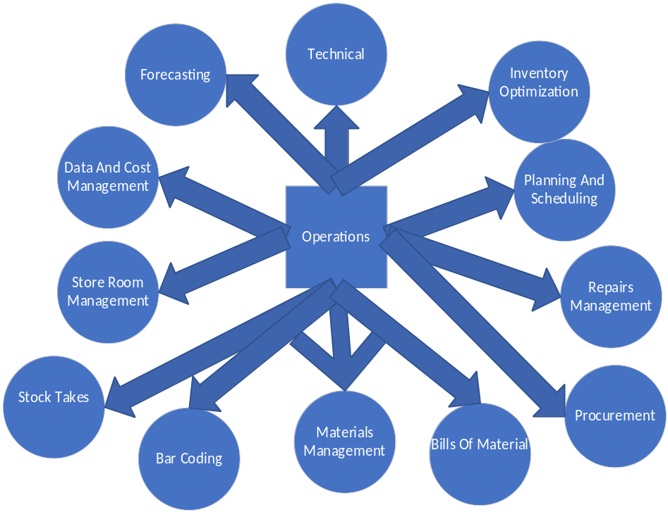

  - Create And Stock
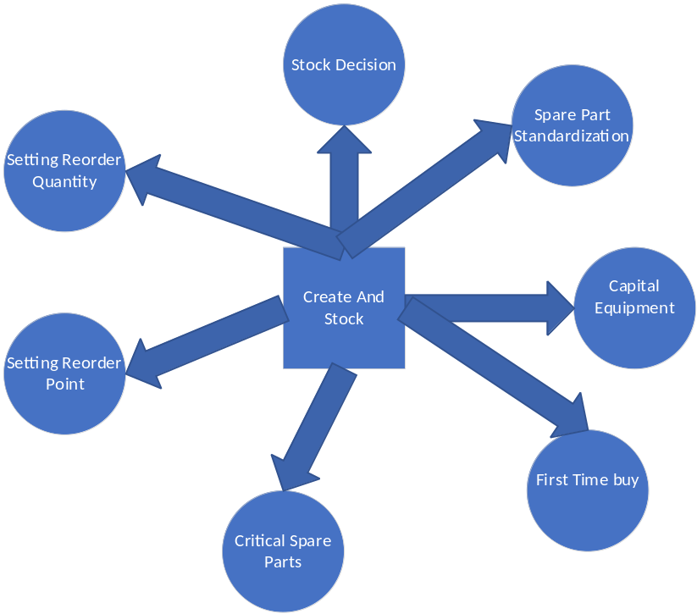

  - Obsolescence
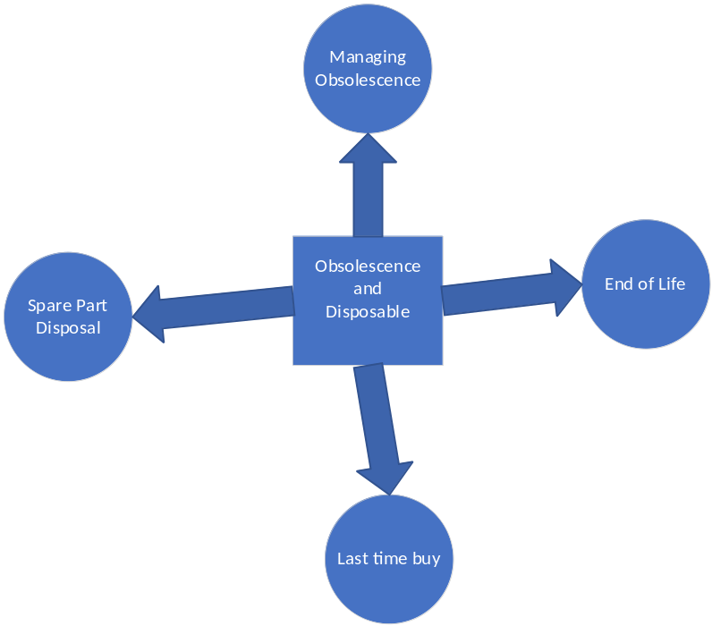

  - Finance
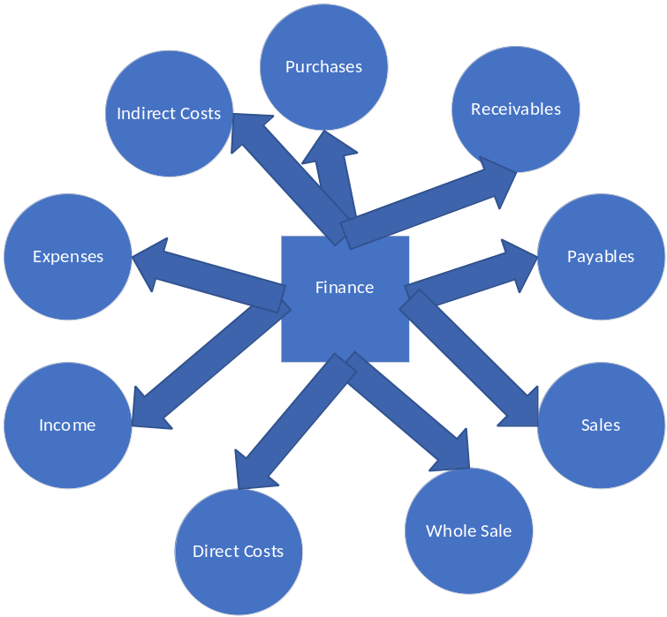

- Application

Sr No | Column | Column Description
1. | Id | Application Id
2. | Application Date | Application Date
3. | Budget | Budget
4. | Counter Party | Party Popup
5. | Target End Date | Target Date
6. | Rate of Interest | Interest Rate
7. | Tenor | Tenor
8. | Net Asset | Net Worth

- Set Inventory Parameters Item Master
Sr No | Column Name | Description
1. | Id | Item ID
2. | Item Code | Item Code
3. | Item Description | Item Description
4. | Min | Minimum Quantity
5. | Max | Maximum Quantity
6. | Reorder Quantity | Reorder Quantity
7. | Reorder Level | Reorder Level
8. | Demand Rate | Demand Rate
9. | Demand Rate Cumulative Type | Popup
10 | Lead Time | Lead Time
11. | Lead Time Cumulative | Popup
12. | Cycle Stock | Cycle Stock
13. | Safety Stock | Safety Stock
14. | Reorder Point | Reorder Point
15. | Average Stock On Hand | Average Stock On Hand
16. | Inventory Reduction | Inventory Reduction
17. | Stockout | Stockout
18. | Inventory Date | Inventory Date

- Jobcard
Sr No | Column Name | Description
1. | Jobcard Id | Id
2. | Transaction Date | Transaction Date
3. | Jobcard Date | Jobcard Date
4. | Job | Job Popup
5. | Supervisor Id | Supervisor Popup
6. | Production Plan Serial No | Plan Serial No
7. | World | World
8. | Country | Country
9. | State | State

- Spare Part System

  - Raw Material Development
Header
Sr No | Column | Column Description
1. | Id | Primary Key
2. | Transaction Date | Transaction Date
3. | Revenue Amount | Revenue Amount received from Budget
4. | From Warehouse Id | Popup
5. | Application Id | Application Id Popup
6. | Jobcard Id | Popup

Detail
Sr No | Column | Column Description
1. | Id | Primary Key
2. | Header Id | Raw Material Header Id
3. | Item Id | Item Popup
4. | Quantity | Quantity
5. | Price | Price
6. | Classification | Classification Popup FSN(Fast, Slow ,Non Moving)

Process
On Input
Credit Raw Material Development Receivables with Revenue Amount
On Authorize
Debit Raw Material Development Receivables
Credit Raw Material Development Purchase
Credit Raw Material Development Payables
Debit Raw Material Development Sales
On Settle
Debit Raw Material Development Purchase
Debit Raw Material Development Payables
Credit Raw Material Development Sales
Update Reorder quantity

ON PURCHASE/SALES/PAYABLES AUTHORISE
Validate Min
Validate Max
Validate Reorder Quantity
Validate Reorder Level
Validate Demand Rate
Validate Demand Rate Cumulative Type
Validate Lead Time
Validate Lead Time Cumulative
Validate Cycle Stock
Validate Safety Stock
Validate Reorder Point
Validate Average Stock On Hand
Validate Inventory Reduction
Validate Stockout

  - Meaningful Product Conversion
Header
Sr No | Column | Column Description
1. | Id | Primary Key
2. | Transaction Date | Transaction Date
3. | Revenue Amount | Revenue Amount
4. | From Warehouse Id | Popup
5. | Application Id | Popup
6. | Finished Product Id | Popup Product Master
7. | Finished Date | Finished Date
8. | Jobcard Id | Popup

Detail
Sr No | Column | Column Description
1. | Id | Primary Key
2. | Header Id | Header Id
3. | Item Id | Item Popup
4. | Quantity | Quantity
5. | Price | Price
6. | Classification | Classification Popup FSN(Fast, Slow ,Non Moving)

Process
On Input
Credit Meaningful Product Conversion Receivables with Revenue Amount
On Authorize
Debit Meaningful Product Conversion Receivables
Credit Meaningful Product Conversion Purchase
Credit Meaningful Product Conversion Payables
Debit Meaningful Product Conversion Sales

On PURCHASE/SALES/PAYABLES AUTHORISE
Update Reorder Quantity
Validate Min
Validate Max
Validate Reorder Quantity
Validate Reorder Level
Validate Demand Rate
Validate Demand Rate Cumulative Type
Validate Lead Time
Validate Lead Time Cumulative
Validate Cycle Stock
Validate Safety Stock
Validate Reorder Point
Validate Average Stock On Hand
Validate Inventory Reduction
Validate Stockout
ON PURCHASE/SALES/PAYABLES AUTHORISE
Debit Meaningful Product Conversion Purchase
Debit Meaningful Product Conversion Payables
Credit Meaningful Product Conversion Sales
Update Reorder quantity
Validate Min
Validate Max
Validate Reorder Quantity
Validate Reorder Level
Validate Demand Rate
Validate Demand Rate Cumulative Type
Validate Lead Time
Validate Lead Time Cumulative
Validate Cycle Stock
Validate Safety Stock
Validate Reorder Point
Validate Average Stock On Hand
Validate Inventory Reduction
Validate Stockout

  - Warehousing

Header
Sr No | Column | Column Description
1. | Id | Primary Key
2. | Transaction Date | Transaction Date
3. | Revenue Amount | Revenue Amount received from Budget
4. | Warehouse Id | Popup
5. | Application Id | Application Id Popup
6. | Jobcard Id | Popup

Detail
Sr No | Column | Column Description
1. | Id | Primary Key
2. | Header Id | Header Id
3. | Item Id | Item Popup
4. | Quantity | Quantity
5. | Price | Price
6. | Classification | Classification Popup FSN(Fast, Slow ,Non Moving)

Process
On Input
Credit Warehousing Receivables with Revenue Amount
On Authorize
Debit Warehousing Receivables
Credit Warehousing Purchase
Credit Warehousing Payables
Debit Warehousing Sales
On PURCHASE/SALES/PAYABLES AUTHORISE
Update Reorder Quantity
Validate Min
Validate Max
Validate Reorder Quantity
Validate Reorder Level
Validate Demand Rate
Validate Demand Rate Cumulative Type
Validate Lead Time
Validate Lead Time Cumulative
Validate Cycle Stock
Validate Safety Stock
Validate Reorder Point
Validate Average Stock On Hand
Validate Inventory Reduction
Validate Stockout

ON PURCHASE/SALES/PAYABLES AUTHORISE
Debit Warehousing Purchase
Debit Warehousing Payables
Credit Warehousing Sales
Update Reorder quantity
Validate Min
Validate Max
Validate Reorder Quantity
Validate Reorder Level
Validate Demand Rate
Validate Demand Rate Cumulative Type
Validate Lead Time
Validate Lead Time Cumulative
Validate Cycle Stock
Validate Safety Stock
Validate Reorder Point
Validate Average Stock On Hand
Validate Inventory Reduction
Validate Stockout

  - Wholesale

Header
Sr No | Column | Column Description
1. | Id | Primary Key
2. | Transaction Date | Transaction Date
3. | Revenue Amount | Revenue Amount received from Budget
4. | Warehouse Id | Popup
5. | Application Id | Application Id Popup
6. | Jobcard Id | Popup

Detail
Sr No | Column | Column Description
1. | Id | Primary Key
2. | Header Id | Header Id
3. | Item Id | Item Popup
4. | Quantity | Quantity
5. | Price | Price
6. | Classification | Classification Popup FSN(Fast, Slow ,Non Moving)

Process
On Input
Credit Wholesale Receivables with Revenue Amount
On Authorize
Debit Wholesale Receivables
Credit Wholesale Purchase
Credit Wholesale Payables
Debit Wholesale Sales
On PURCHASE/SALES/PAYABLES AUTHORISE
Update Reorder Quantity
Validate Min
Validate Max
Validate Reorder Quantity
Validate Reorder Level
Validate Demand Rate
Validate Demand Rate Cumulative Type
Validate Lead Time
Validate Lead Time Cumulative
Validate Cycle Stock
Validate Safety Stock
Validate Reorder Point
Validate Average Stock On Hand
Validate Inventory Reduction
Validate Stockout

ON PURCHASE/SALES/PAYABLES AUTHORISE
Debit Wholesale Purchase
Debit Wholesale Payables
Credit Wholesale Sales
Update Reorder quantity.

Validate Min
Validate Max
Validate Reorder Quantity
Validate Reorder Level
Validate Demand Rate
Validate Demand Rate Cumulative Type
Validate Lead Time
Validate Lead Time Cumulative
Validate Cycle Stock
Validate Safety Stock
Validate Reorder Point
Validate Average Stock On Hand
Validate Inventory Reduction
Validate Stockout

  - Delivery To Customer

Header
Sr No | Column | Column Description
1. | Id | Primary Key
2. | Transaction Date | Date
3. | Application Id | Popup
4. | Customer Id | Popup
5. | Delivery Date | Date
6. | Jobcard Id | Popup
7. | Freight Id | Popup
8. | Type of delivery | Popup
9. | Freight charges | Amount
10. | Delivery Status | Drop Down

Detail
Sr No | Column | Column Description
1. | Id | Primary Key
2. | Header Id | Header Id
3. | Item Id | Item Popup
4. | Quantity | Quantity
5. | Price | Price
6. | Classification | Classification Popup FSN(Fast, Slow ,Non Moving)

Process
On Input
- Credit Expenses Accounts with Charges

On Authorize
- Update Delivery Status
- Debit Expenses Accounts with Charges

  - Issue To Customer

Header
Sr No | Column | Column Description
1. | Id | Primary Key
2. | Transaction Date | Date
3. | Application Id | Popup
4. | Customer Id | Popup
5. | Delivery Date | Date
6. | Jobcard Id | Popup
7. | Issue Slip No | Issue Slip
8. | Warehouse Id | Popup
9. | Issue Amount | Amount
10. | Issue Date | Date

Detail
Sr No | Column | Column Description
1. | Id | Primary Key
2. | Header Id | Header Id
3. | Item Id | Item Popup
4. | Quantity | Quantity
5. | Price | Price
6. | Classification | Classification Popup FSN(Fast, Slow ,Non Moving)

Process
On Input
- Debit Income Accounts with Amount

On Authorize

- Credit Income Accounts with Amount

  - Material Repair and Operations
Header
Sr No | Column | Column Description
1. | Id | Primary Key
2. | Transaction Date | Transaction Date
3. | Revenue Amount | Revenue Amount
4. | From Warehouse Id | Popup
5. | Application Id | Popup
6. | Product Id | Popup Product Master
7. | Customer Id | Popup
8. | Jobcard Id | Popup

Detail
Sr No | Column | Column Description
1. | Id | Primary Key
2. | Header Id | Header Id
3. | Item Id | Item Popup
4. | Quantity | Quantity
5. | Price | Price
6. | Classification | Classification Popup FSN(Fast, Slow ,Non Moving)

Process
On Input
Credit Material Repair Receivables with Revenue Amount
On Authorize
Debit Material Repair Receivables
Credit Material Repair Purchase
Credit Material Repair Payables
Debit Material Repair Sales
ON PURCHASE/SALES/PAYABLES AUTHORISE
Debit Material Repair Purchase
Debit Material Repair Payables
Credit Material Repair Sales

On PURCHASE/SALES/PAYABLES AUTHORISE
Update Reorder Quantity
Validate Min
Validate Max
Validate Reorder Quantity
Validate Reorder Level
Validate Demand Rate
Validate Demand Rate Cumulative Type
Validate Lead Time
Validate Lead Time Cumulative
Validate Cycle Stock
Validate Safety Stock
Validate Reorder Point
Validate Average Stock On Hand
Validate Inventory Reduction
Validate Stockout

  - Customer Storage
Header
Sr No | Column | Column Description
1. | Id | Primary Key
2. | Transaction Date | Transaction Date
3. | Revenue Amount | Revenue Amount received from Budget
4. | Warehouse Id | Popup
5. | Application Id | Application Id Popup
6. | Jobcard Id | Popup
7. | Customer Id | Popup

Detail
Sr No | Column | Column Description
1. | Id | Primary Key
2. | Header Id | Header Id
3. | Item Id | Item Popup
4. | Quantity | Quantity
5. | Price | Price
6. | Classification | Classification Popup FSN(Fast, Slow ,Non Moving)

Process
On Input
Credit Customer Storage Receivables with Revenue Amount
On Authorize
Debit Customer Storage Receivables
Credit Customer Storage Purchase
Credit Customer Storage Payables
Debit Customer Storage Sales
ON PURCHASE/SALES/PAYABLES AUTHORISE
Debit Customer Storage Purchase
Debit Customer Storage Payables
Credit Customer Storage Sales
On PURCHASE/SALES/PAYABLES AUTHORISE
Update Reorder Quantity
Validate Min
Validate Max
Validate Reorder Quantity
Validate Reorder Level
Validate Demand Rate
Validate Demand Rate Cumulative Type
Validate Lead Time
Validate Lead Time Cumulative
Validate Cycle Stock
Validate Safety Stock
Validate Reorder Point
Validate Average Stock On Hand
Validate Inventory Reduction
Validate Stockout

- Operations

  - Planning And Scheduling

Sr No | Column | Column Description
1. | Id | Primary Key
2. | Process Id | Popup All the processes in Spares Inventory System
3. | PlannedStartDate | Date
4. | PlannedEndDate | Date
5. | Transaction Date | Transaction

  - Materials Management System

    - Appointment Setting
Sr No | Column | Column Description
1. | Id | Primary Key
2. | Customer Id | Popup
3. | Transaction Date | Transaction Date
4. | Appointment Date | Appointment Date
6. | Application Id | Popup

    - Materials Requisition

Header
Sr No | Column | Column Description
1. | Id | Primary Key
2. | Transaction Date | Transaction Date
3. | Amount | Revenue Amount received from Budget
4. | Warehouse Id | Popup
5. | Application Id | Application Id Popup
6. | Jobcard Id | Popup

Detail
Sr No | Column | Column Description
1. | Id | Primary Key
2. | Header Id | Header Id
3. | Item Id | Item Popup
4. | Quantity | Quantity
5. | Price | Price
6. | Classification | Classification Popup FSN(Fast, Slow ,Non Moving)

Process
On Input
Credit Material Requisition Indirect Cost with Amount

On Authorize
Debit Material Requisition Indirect Cost with Amount

    - Issue Slip within Warehouse

Header
Sr No | Column | Column Description
1. | Id | Primary Key
2. | Transaction Date | Transaction Date
3. | Amount | Revenue Amount received from Budget
4. | Warehouse Id | Popup
5. | Application Id | Application Id Popup
6. | Jobcard Id | Popup

Detail
Sr No | Column | Column Description
1. | Id | Primary Key
2. | Header Id | Header Id
3. | Item Id | Item Popup
4. | Quantity | Quantity
5. | Price | Price
6. | Classification | Classification Popup FSN(Fast, Slow ,Non Moving)

Process
On Input
Credit Issue Slip to Warehouse Indirect Cost with Amount

On Authorize
Debit Issue Slip to Warehouse Indirect Cost with Amount

    - Goods Receipt Note

Header
Sr No | Column | Column Description
1. | Id | Primary Key
2. | Transaction Date | Transaction Date
3. | Amount | Revenue Amount received from Budget
4. | Warehouse Id | Popup
5. | Application Id | Application Id Popup
6. | Jobcard Id | Popup

Detail
Sr No | Column | Column Description
1. | Id | Primary Key
2. | Header Id | Header Id
3. | Item Id | Item Popup
4. | Quantity | Quantity
5. | Price | Price
6. | Classification | Classification Popup FSN(Fast, Slow ,Non Moving)

Process
On Input
Credit Goods Receipt Note Indirect Cost with Amount

On Authorize
Debit Goods Receipt Note Indirect Cost with Amount

    - Delivery Challan to Warehouse

Header
Sr No | Column | Column Description
1. | Id | Primary Key
2. | Transaction Date | Transaction Date
3. | Amount | Revenue Amount received from Budget
4. | From Warehouse Id | Popup
5. | Application Id | Application Id Popup
6. | Jobcard Id | Popup
7. | To Warehouse Id | Popup

Detail
Sr No | Column | Column Description
1. | Id | Primary Key
2. | Header Id | Header Id
3. | Item Id | Item Popup
4. | Quantity | Quantity
5. | Price | Price
6. | Classification | Classification Popup FSN(Fast, Slow ,Non Moving)

Process
On Input
Debit Delivery Challan Indirect Cost with Amount

On Authorize
Credit Delivery Challan Indirect Cost with Amount

    - Letter Of Credit

Sr No | Column | Column Description
1. | Id | Primary Key
2. | Transaction Date | Transaction Date
3. | Amount | Revenue Amount received from Budget
4. | Warehouse Id | Popup
5. | Application Id | Application Id Popup
6. | Jobcard Id | Popup
7. | Letter Of Credit Date | Date
8. | Import /Export Flag | I or E
9. | Country | Popup
10. | Bank Code | Popup
11. | Shipment Id | Popup
12. | Cost | Cost

On Input
Debit Letter Of Credit Direct Cost with Cost

On Authorize
Credit Letter Of Credit Direct Cost with Cost

    - Recycled Materials

Header
Sr No | Column | Column Description
1. | Id | Primary Key
2. | Transaction Date | Transaction Date
3. | Amount | Revenue Amount received from Budget
4. | Warehouse Id | Popup
5. | Application Id | Application Id Popup
6. | Jobcard Id | Popup
7. | Recycle Date | Date

Detail
Sr No | Column | Column Description
1. | Id | Primary Key
2. | Header Id | Raw Material Header Id
3. | Item Id | Item Popup
4. | Quantity | Quantity
5. | Price | Price
6. | Classification | Classification Popup FSN(Fast, Slow ,Non Moving)

Process
On Input
Credit Recycle Indirect Cost with Amount

On Authorize
Debit Recycle Indirect Cost with Amount

  - Shipment Management
Header
Sr No | Column | Column Description
1. | Id | Primary Key
2. | Transaction Date | Transaction Date
3. | Amount | Revenue Amount received from Budget
4. | Warehouse Id | Popup
5. | Application Id | Application Id Popup
6. | Jobcard Id | Popup
7. | Carrier Id | Popup
8. | Estimated Time Of Arrival | Date
9. | Customer Id | Popup
10. | Shipment Date | Date

Detail
Sr No | Column | Column Description
1. | Id | Primary Key
2. | Header Id | Header Id
3. | Item Id | Item Popup
4. | Quantity | Quantity
5. | Price | Price
6. | Classification | Classification Popup FSN(Fast, Slow ,Non Moving)

Process
On Input
Credit Shipment Expenses with Amount

On Authorize
Debit Shipment Expenses with Amount

  - Procurement
Header
Sr No | Column | Column Description
1. | Id | Primary Key
2. | Transaction Date | Transaction Date
3. | Amount | Revenue Amount received from Budget
4. | Warehouse Id | Popup
5. | Application Id | Application Id Popup
6. | Jobcard Id | Popup
7. | Legal Id | Popup
8. | Procurement Date | Date
9. | Customer Id | Popup
10. | Department Id | Popup

Detail
Sr No | Column | Column Description
1. | Id | Primary Key
2. | Header Id | Header Id
3. | Item Id | Item Popup
4. | Quantity | Quantity
5. | Price | Price
6. | Classification | Classification Popup FSN(Fast, Slow ,Non Moving)

Process
On Input
Credit Procurement Expenses with Amount

On Authorize
Debit Procurement Expenses with Amount

  - Bill Of Material

Header
Sr No | Column | Column Description
1. | Id | Primary Key
2. | Transaction Date | Transaction Date
3. | Amount | Revenue Amount received from Budget
4. | Warehouse Id | Popup
5. | Application Id | Application Id Popup
6. | Jobcard Id | Popup
7. | Legal Id | Popup
8. | Bill Date | Date
9. | Customer Id | Popup

Detail
Sr No | Column | Column Description
1. | Id | Primary Key
2. | Header Id | Header Id
3. | Item Id | Item Popup
4. | Quantity | Quantity
5. | Price | Price
6. | Classification | Classification Popup FSN(Fast, Slow ,Non Moving)

Process
On Input
Debit Bill Of Material Income with Amount

On Authorize
Credit Bill Of Material Income with Amount

  - Bar coding

Sr No | Column | Column Description
1. | Id | Primary Key
2. | Item Code | Popup
3. | Bar Code Serial No | Barcode Serial No
4. | QR Code 2D Symbol | Bitmap

  - Stock Takes
Sr No | Column | Column Description
1. | Id | Primary Key
2. | Transaction Date | Date
3. | Item Code | Popup
4. | Quantity On Hand | Quantity On Hand When stock take
5. | Quantity Required | Quantity Required When Stock Take
6. | Supplier Code | Popup
7. | Stock Take Date | Date
8. | Reorder Level When Stock Take | Reorder Quantity
9. | Application Id | Popup

  - Inventory Optimization
    - Forecasting

Sr No | Column | Column Description
1. | Id | Primary Key
2. | Transaction Date | Transaction Date
3. | Forecast for Year | Year
4. | Forecast for Quarter | 1st ,2nd ,3rd or 4th Quarter
5. | Profit predicted | Profit predicted
6. | Loss Predicted | Loss Predicted
7. | Ledger Id | Ledger Id
8. | Ledger Description | Ledger Description

    - Events
Header
Sr No | Column | Column Description
1. | Id | Primary Key
2. | Transaction Date | Transaction Date
3. | Revenue Amount | Revenue Amount received from Budget
4. | From Warehouse Id | Popup
5. | Application Id | Application Id Popup
6. | Jobcard Id | Popup
7. | VenueId | Popup
8. | Event Date | Date

Detail
Sr No | Column | Column Description
1. | Id | Primary Key
2. | Header Id | Raw Material Header Id
3. | Item Id | Item Popup
4. | Quantity | Quantity
5. | Price | Price
6. | Classification | Classification Popup FSN(Fast, Slow ,Non Moving)

Process
On Input
Credit Events Receivables with Revenue Amount
On Authorize
Debit Events Development Receivables
Credit Events Purchase
Credit Events Payables
Debit Events Sales
ON PURCHASE/SALES/PAYABLES AUTHORISE
Debit Events Purchase
Debit Events Payables
Credit Events Sales
Update Reorder quantity
Validate Min
Validate Max
Validate Reorder Quantity
Validate Reorder Level
Validate Demand Rate
Validate Demand Rate Cumulative Type
Validate Lead Time
Validate Lead Time Cumulative
Validate Cycle Stock
Validate Safety Stock
Validate Reorder Point
Validate Average Stock On Hand
Validate Inventory Reduction
Validate Stockout
On PURCHASE/SALES/PAYABLES AUTHORISE
Update Reorder Quantity
Validate Min
Validate Max
Validate Reorder Quantity
Validate Reorder Level
Validate Demand Rate
Validate Demand Rate Cumulative Type
Validate Lead Time
Validate Lead Time Cumulative
Validate Cycle Stock
Validate Safety Stock
Validate Reorder Point
Validate Average Stock On Hand
Validate Inventory Reduction
Validate Stockout

    - Seasonality
      - Excessive Stock
Sr No | Column | Column Description
1. | Id | Primary Key
2. | Item Code | Popup
3. | QuantityExcess | Excessive quantity
4. | QuantityOnHand | Quantity on hand
5. | Excessive Stock Date | Date on which stock was excessive
6. | ExcessCost | Excess stock cost

On Input
Credit Excessive Stock with Excess Stock

On Authorize

Debit Excessive Stock with Excess Stock

      - Offload Slow-selling Inventory
Sr No | Column | Column Description
1. | Id | Primary Key
2. | Item Code | Popup
3. | Quantity Slow Selling Stock | Slow Selling Stock quantity
4. | QuantityOnHand | Quantity on hand
5. | Slow Selling Stock Date | Date on which stock was declared slow selling
6. | SlowSellingStockCost | SlowSellingStockCost

Process
On Input
Credit Slow Selling Stock with Excess SlowSellingStockCost

On Authorize

Debit Slow Selling Stock with Excess SlowSellingStockCost

      - Use Predictive Analysis Report
      - Offer Package Deals
Sr No | Column | Column Description
1. | Id | Primary Key
2. | Application Id | Popup
3. | Customer Id | Popup
4. | Transaction Date | Date
5. | Deal Date | Date
6. | Deal End Date | Date
7. | Total Discount Price | Discount
8. | Venue Id | Popup

Sr No | Column | Column Description
1. | Id | Primary Key
2. | Item Code | Popup
3. | Price After Discount | Price After Discount
4. | Header Id | Header

Process
On Input
Debit Package Deal Direct Cost with Total Discount Price
On Authorize
Credit Package Deal Direct Cost with Total Discount Price
Update Reorder quantity
Validate Min
Validate Max
Validate Reorder Quantity
Validate Reorder Level
Validate Demand Rate
Validate Demand Rate Cumulative Type
Validate Lead Time
Validate Lead Time Cumulative
Validate Cycle Stock
Validate Safety Stock
Validate Reorder Point
Validate Average Stock On Hand
Validate Inventory Reduction
Validate Stockout

On PURCHASE/SALES/PAYABLES AUTHORISE
Update Reorder Quantity
Validate Min
Validate Max
Validate Reorder Quantity
Validate Reorder Level
Validate Demand Rate
Validate Demand Rate Cumulative Type
Validate Lead Time
Validate Lead Time Cumulative
Validate Cycle Stock
Validate Safety Stock
Validate Reorder Point
Validate Average Stock On Hand
Validate Inventory Reduction
Validate Stockout

      - Streamline Order Fulfillment

        - Returns
Header Returns
Sr No | Column | Column Description
1. | Id | Primary Key
2. | Sales Order Id | Popup Sales Order
3. | Receipt No | Receipt No
4. | Delivery No | Popup Delivery to Customer
5. | Total Price Of Returns | Total Price Of Returns

Detail Returns
Sr No | Column | Column Description
1. | Id | Primary Key
2. | Return Date | Date
3. | Price | Total Price of Return
4. | Item Code | Popup

Process
On Input
Credit Returns Direct Cost with Total Price Of Returns

On Authorize
Debit Returns Direct Cost with Total Price Of Returns

        - Picking
Header Picking
Sr No | Column | Column Description
1. | Id | Primary Key
2. | Sales Order Id | Popup Sales Order
3. | Receipt No | Receipt No
4. | Delivery No | Popup Delivery to Customer
5. | Picker Id | Picker Id
6. | Total Price of Picking | Total Price Of Picking

Detail Picking
Sr No | Column | Column Description
1. | Id | Primary Key
2. | Picking Date | Date
3. | Price | Price
4. | Item Code | Popup

Process
On Input
Credit Picking Direct Cost with Total Price Of Returns

On Authorize
Debit Picking Direct Cost with Total Price Of Returns

    - Stock Out
Sr No | Column | Column Description
1. | Id | Primary Key
2. | Transaction Date | Transaction Date
3. | ItemCode | Popup
4. | QOH when Stock Out | QOH when stock out
5. | StockOutQuantity | Quantity excess than qoh
6. | Price | Price

Process
On Input
Credit Stockout Indirect Costs with Price

On Authorize
Debit Stockout Indirect Costs with Price

    - Holding Costs
Sr No | Column | Column Description
1. | Id | Primary Key
2. | Transaction Date | Transaction Date
3. | ItemCode | Popup
4. | QOH Unsold | QOH Unsold

Process
On Input
Credit Holding Costs Indirect Costs with Price

On Authorize
Debit Holding Costs Indirect Costs with Price

    - Safety Stock
Sr No | Column | Column Description
1. | Id | Primary Key
2. | Transaction Date | Transaction Date
3. | ItemCode | Popup
4. | SafetyQuantity | Safety Quantity
5. | Price | Price

Process
On Input
Debit Safety Stock Costs Indirect Costs with Price

On Authorize
Credit Safety Stock Costs Indirect Costs with Price

    - Lead Time
Sr No | Column | Column Description
1. | Id | Primary Key
2. | Transaction Date | Transaction Date
3. | Lead Time in hours | Time taken between Purchase and receipt of goods
4. | Purchaseorderid | Popup

  - Store Room
  - Technical Management
    - Assets to be maintained

Header
Sr No | Column | Column Description
1. | Id | Primary Key
2. | Transaction Date | Transaction Date
3. | Amount | Revenue Amount received from Budget
4. | Warehouse Id | Popup
5. | Application Id | Application Id Popup
6. | Jobcard Id | Popup
7. | Maintenance Id | Popup from Maintenance Master Sample Data  Preventive Maintenance  Predictive Maintenance  Fixed Interval Maintenance  Run To Failure  Condition Based Maintenance

Detail
Sr No | Column | Column Description
1. | Id | Primary Key
2. | Header Id | Header Id
3. | Item Id | Item Popup
4. | Quantity | Quantity
5. | Price | Price
6. | Classification | Classification Popup FSN(Fast, Slow ,Non Moving)

On Input
Debit Asset Maintenance Indirect Cost with Amount
On Authorize
Credit Asset Maintenance Indirect Cost with Amount

    - Assets Failed
Header
Sr No | Column | Column Description
1. | Id | Primary Key
2. | Transaction Date | Transaction Date
3. | Amount | Revenue Amount received from Budget
4. | Warehouse Id | Popup
5. | Application Id | Application Id Popup
6. | Jobcard Id | Popup
7. | Failure Reason Id | Popup

Detail
Sr No | Column | Column Description
1. | Id | Primary Key
2. | Header Id | Header Id
3. | Item Id | Item Popup
4. | Quantity | Quantity
5. | Price | Price
6. | Classification | Classification Popup FSN(Fast, Slow ,Non Moving)

On Input
Credit Asset Failed Indirect Cost with Amount
On Authorize
Debit Asset Failed Indirect Cost with Amount

- Create And Stock
  - Stock Decision
    - Single Echelon
Sr No | Column | Column Description
1. | Id | Primary Key
2. | Warehouse Id | Popup Warehouse
3. | Site Id | Popup
4. | Application Id | Popup
5. | Transaction Date | Date

    - Multi Echelon
Sr No | Column | Column Description
1. | Id | Primary Key
2. | Siteid | Popup
3. | Application Id | Popup
4. | Transaction Date | Date

Sr No | Column | Column Description
1. | Id | Primary Key
2. | Warehouse Id | Popup
3. | Header Id | Header Id

  - Spare Part Standardization
Sr No | Column | Column Description
1. | Id | Primary Key
2. | Item Code | Popup
3. | ISO Id | Popup International Standard Organization Code
4. | Transaction Date | Date

  - Capital Equipment
Sr No | Column | Column Description
1. | Id | Primary Key
2. | Transaction Date | Date
3. | Application Id | Popup
4. | Revenue Amount | Amount

Sr No | Column | Column Description
1. | Id | Primary Key
2. | Header Id | Header Id
3. | Product Id | Popup
4. | Price | Price

Process
On Input
Credit Capital Equipment Receivables with Revenue Amount
On Authorize
Debit Capital Equipment Receivables with Revenue Amount
Credit Capital Equipment Purchase with Revenue Amount
Credit Capital Equipment Payables with Revenue Amount
Debit Events Sales with Revenue Amount
ON PURCHASE/SALES/PAYABLES AUTHORISE
Debit Capital Equipment Purchase with Revenue Amount
Debit Capital Equipment Payables with Revenue Amount
Credit Capital Equipment Sales with Revenue Amount
Update Reorder quantity
Validate Min
Validate Max
Validate Reorder Quantity
Validate Reorder Level
Validate Demand Rate
Validate Demand Rate Cumulative Type
Validate Lead Time
Validate Lead Time Cumulative
Validate Cycle Stock
Validate Safety Stock
Validate Reorder Point
Validate Average Stock On Hand
Validate Inventory Reduction
Validate Stockout
On PURCHASE/SALES/PAYABLES AUTHORISE
Update Reorder Quantity
Validate Min
Validate Max
Validate Reorder Quantity
Validate Reorder Level
Validate Demand Rate
Validate Demand Rate Cumulative Type
Validate Lead Time
Validate Lead Time Cumulative
Validate Cycle Stock
Validate Safety Stock
Validate Reorder Point
Validate Average Stock On Hand
Validate Inventory Reduction
Validate Stockout

  - First Time Buy
Sr No | Column | Column Description
1. | Id | Primary Key
2. | Transaction Date | Date
3. | Application Id | Popup
4. | Amount | Amount

Sr No | Column | Column Description
1. | Id | Primary Key
2. | Header Id | Header Id
3. | Product Id | Popup
4. | Price | Price

Process
On Input
Credit First Time Buy Expenses
On Authorize
Debit First Time Buy Expenses
  - Critical Spare Parts
Header
Sr No | Column | Column Description
1. | Id | Primary Key
2. | Transaction Date | Date
3. | Application Id | Popup
4. | Amount | Amount

Detail
Sr No | Column | Column Description
1. | Id | Primary Key
2. | Header Id | Header Id
3. | Item Id | Popup
4. | Price | Price

Process
On Input
Debit Critical Spare Parts Indirect Cost

On Authorize
Credit Critical Spare Parts Indirect Cost

- Obsolescence And Disposal
  - End Of Life
Header
Sr No | Column | Column Description
1. | Id | Primary Key
2. | Transaction Date | Date
3. | Application Id | Popup
4. | Amount | Amount

Detail
Sr No | Column | Column Description
1. | Id | Primary Key
2. | Header Id | Header Id
3. | Item Id | Popup
4. | Price | Price

Process
On Input
Debit End Of Life Indirect Cost with amount

On Authorize
Credit End Of Life Indirect Cost with Amount

  - Last time buy
Header
Sr No | Column | Column Description
1. | Id | Primary Key
2. | Transaction Date | Date
3. | Application Id | Popup
4. | Amount | Amount

Detail
Sr No | Column | Column Description
1. | Id | Primary Key
2. | Header Id | Header Id
3. | Item Id | Popup
4. | Price | Price

Process
On Input
Credit Last Time Buy Indirect Cost with amount

On Authorize
Debit Last Time Buy Indirect Cost with Amount

  - Spare Part Disposal
Header
Sr No | Column | Column Description
1. | Id | Primary Key
2. | Transaction Date | Date
3. | Application Id | Popup
4. | Amount | Amount

Detail
Sr No | Column | Column Description
1. | Id | Primary Key
2. | Header Id | Header Id
3. | Item Id | Popup
4. | Price | Price

Process
On Input
Debit Spare Part Disposal Indirect Cost with amount

On Authorize
Credit Spare Part Disposal Indirect Cost with amount

