`
Contents
1. Data Flow Diagrams 4
1.1 Context Analysis Diagram 4
1.2 Phases 5
1.3 Preplanning 5
1.4 Planning 6
1.5 Control 7
1.6 Budget Capital 8
1.7 B2C Production Costs 8
1.8 Supply Reporting 9
1.9 Equilibrium Pricing 10
1.10 Short Run 11
1.11 Long Run 11
1.12 Material Layout Plan 12
1.13 Electrical 12
1.14 Fuel 13
1.15 Water 13
1.16 Plant Flow Pattern 14
1.17 Plant Roof 15
1.18 Plant Layout Phases 16
1.19 Systematic Layout Planning 16
1.20 Capacity Planning 17
1.21 Capacity Planning Strategy 17
1.22 Capacity Planning Factors 18
1.23 Rough Cut Planning 18
1.24 Capacity Measures 19
1.25 Machine Capacity Assessment 20
1.26 Capacity Planning Load 20
1.27 Aggregate Planning Inputs 20
1.28 Aggregate Planning Strategies 21
1.29 Routing 22
1.30 Route Sheet 23
1.31 Route Card 24
1.32 Scheduling Levels 24
1.33 Detailed Schedules 25
1.34 Scheduling Issues 25
1.35 Manufacturing Lead Time 26
1.36 Loading 26
1.37 Appropriate Machine Choice 27
1.38 Priority Sequencing 27
1.39 Master Production Schedule 28
1.40 Master Production Schedules Inputs 29
1.41 Material Requirement Planning 30
1.42 Scheduling Types 31
1.43 Master Production Schedule Issues 32
1.44 Production Sequencing 32
1.45 Line Balancing 33
1.46 Machine Interference 33
1.47 Record Operational Timings 34
1.48 Production planning and scheduling formats 34
1.49 Progress Control formats 35
1.50 Componentwise operational timings 35
1.51 Machinewise operational timings 36
1.52 Machine capacities 36
1.53 Process Planning layouts 37
1.54 Route Sheet 38
1.55 Job Order 39
1.56 Facilities Maintenance Order 40
1.57 Material Warrant Raw Material 41
1.58 Material Warrant/General Supplies 41
1.59 Time Ticket 42
1.60 Move Order 42
1.61 Inspection Order 43
1.62 Indent Request 43
2. Application 44
3. Jobcard 44
4. Route Sheet 45
5. Route Card 45
6. Capacity Planning 46
6.1 Demand Forecasts 46
6.2 Plant and Labor Efficiency 48
6.3 Subcontracting 50
6.4 Multiple Shift 52
7. Aggregate Planning 54
7.1 Pricing Differentials and Promotions 54
7.2 Back Ordering 56
7.3 Generate Demand 58
7.4 Seasonal Hiring 60
7.5 Subcontracting 62
7.6 Inventory 65
8. Materials Planning 67
8.1 Weighted Average 67
9. Tools Planning 67
9.1 Forecasting 67
9.1.1 Straight Line Forecasting per ledger 67
9.1.2 Moving Averages per ledger 67
9.1.3 Simple Linear Regression per ledger 67
9.1.4 Multiple Linear Regression 67
9.2 Contingency Planning 67
9.3 Scenario Planning 68
9.4 Benchmarking Analysis 68
10. Time Ticket 69
8. Facilities Order 70
9. Workorder Estimate 70
10. Material Warrant Components/Raw Material 70
11. Material Warrant Components/General Supplies 71
12. Move Order 71
` 72
13. Inspection Order 72

- Data Flow Diagrams

  - Context Analysis Diagram
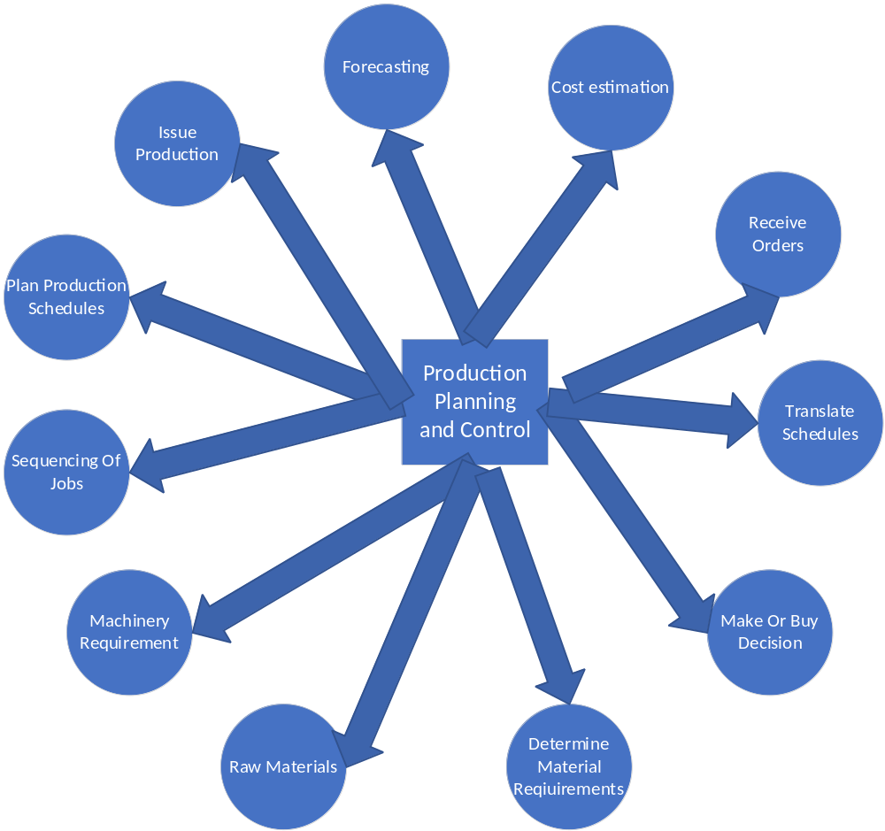

  - Phases

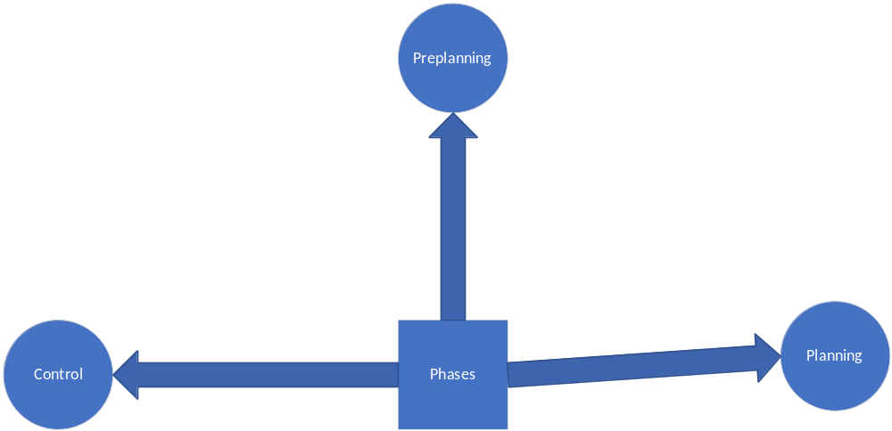

  - Preplanning
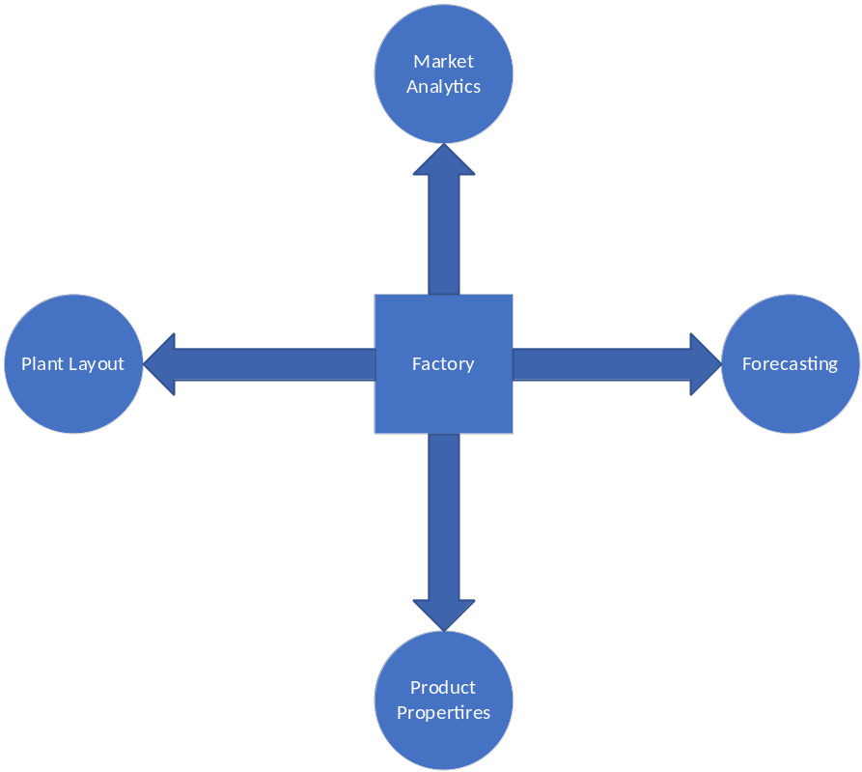

  - Planning
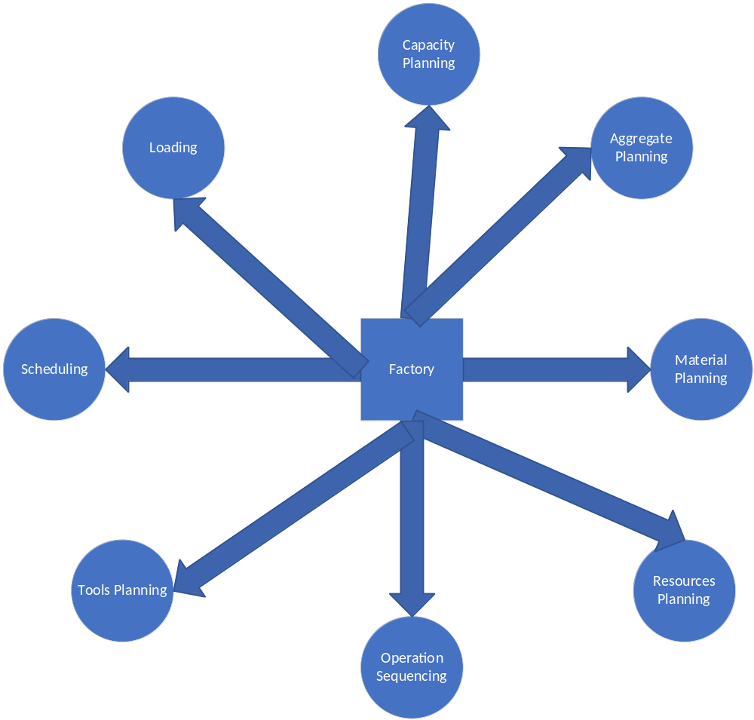

  - Control

  - Budget Capital
*

  - B2C Production Costs

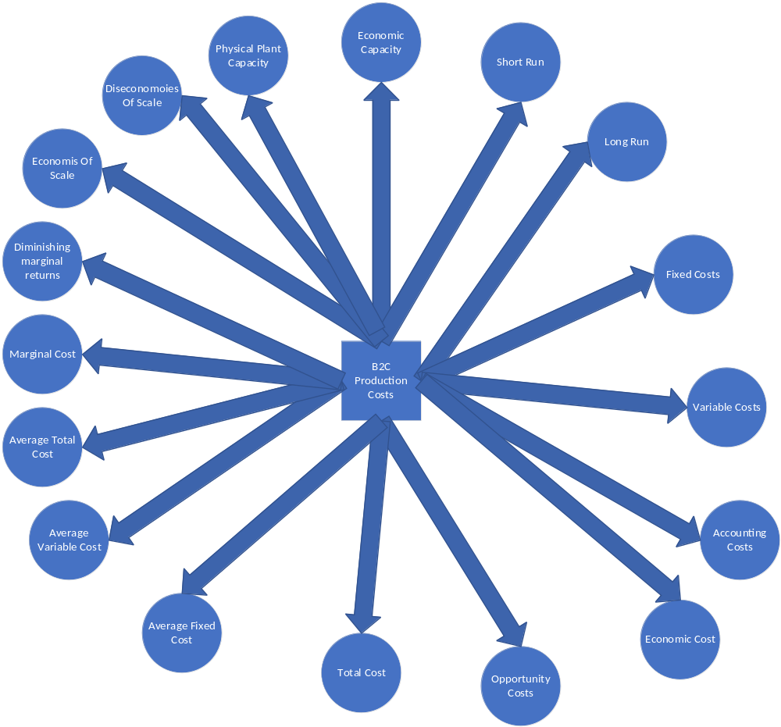

-

  - Supply Reporting

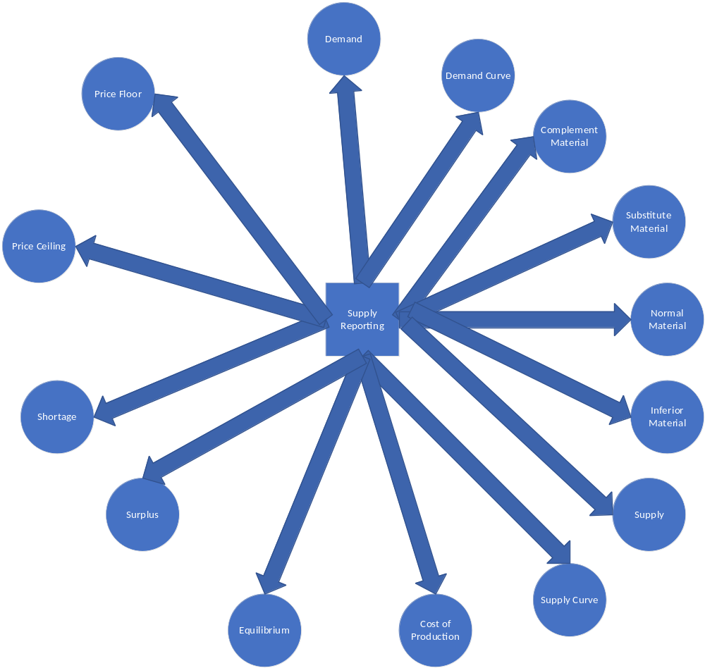

  - Equilibrium Pricing

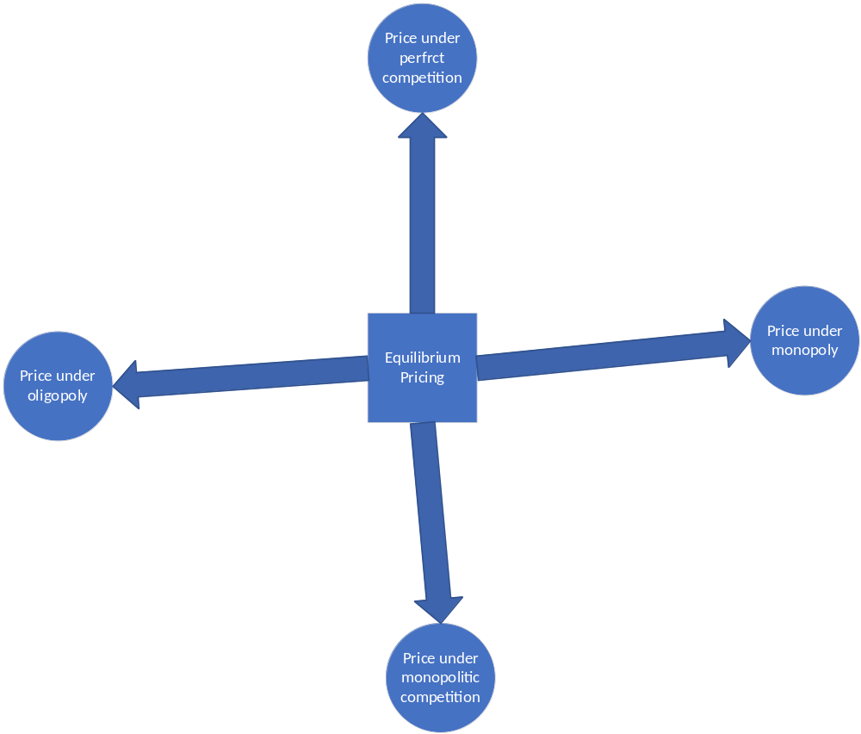

  - Short Run

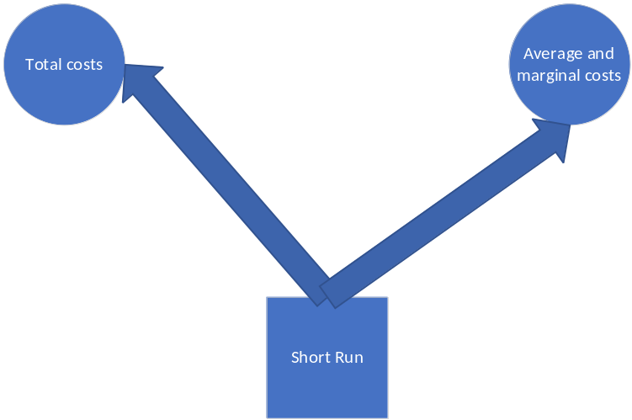

  - Long Run

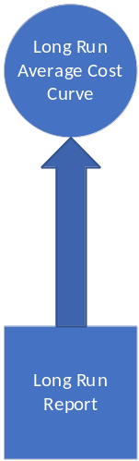

  - Material Layout Plan

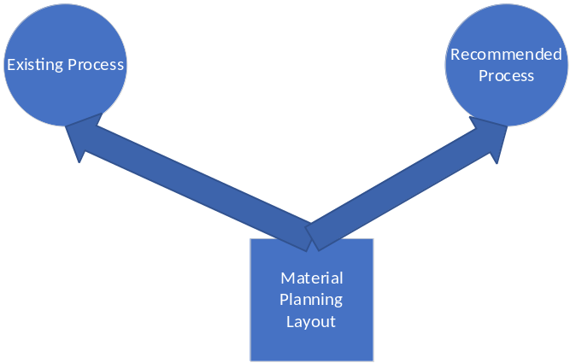

  - Electrical

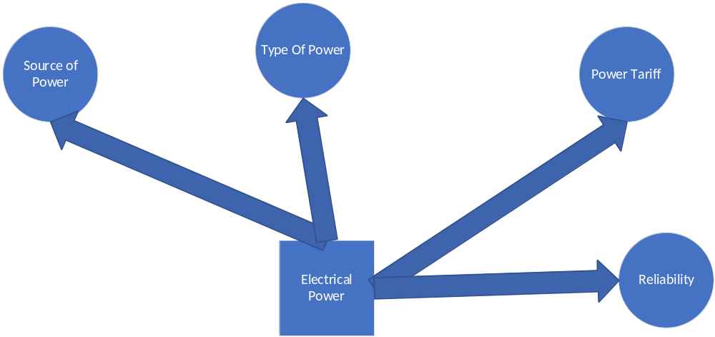

  - Fuel

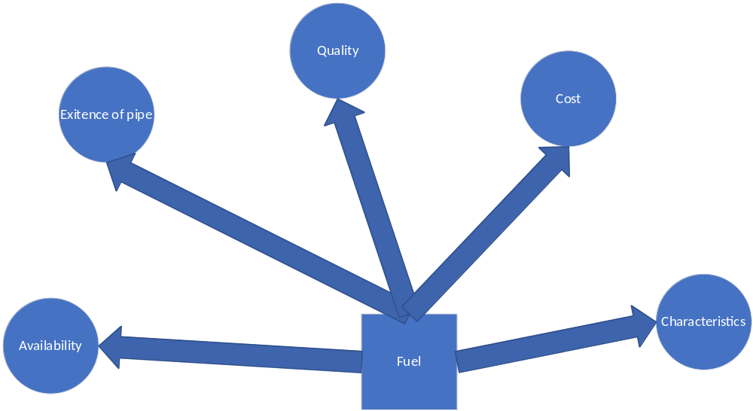

  - Water

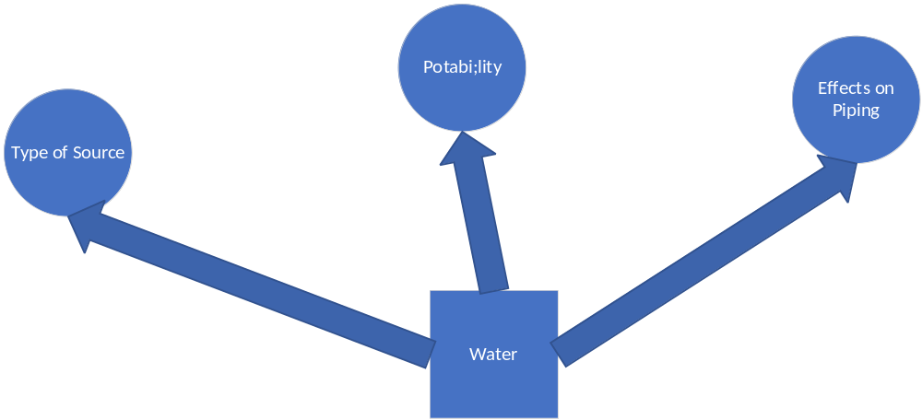

  - Plant Flow Pattern
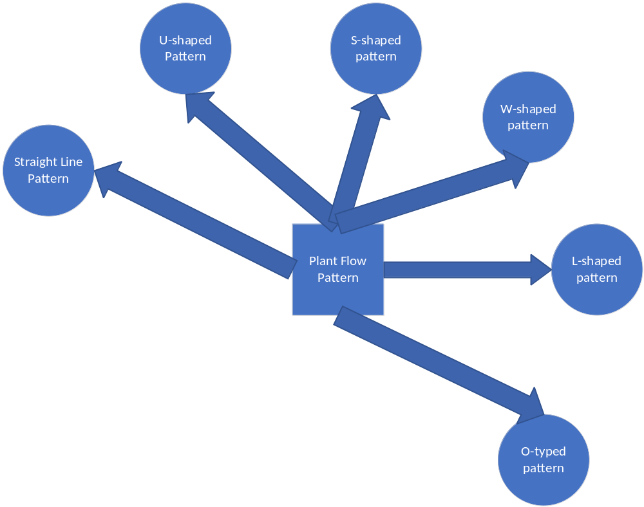

  - Plant Roof

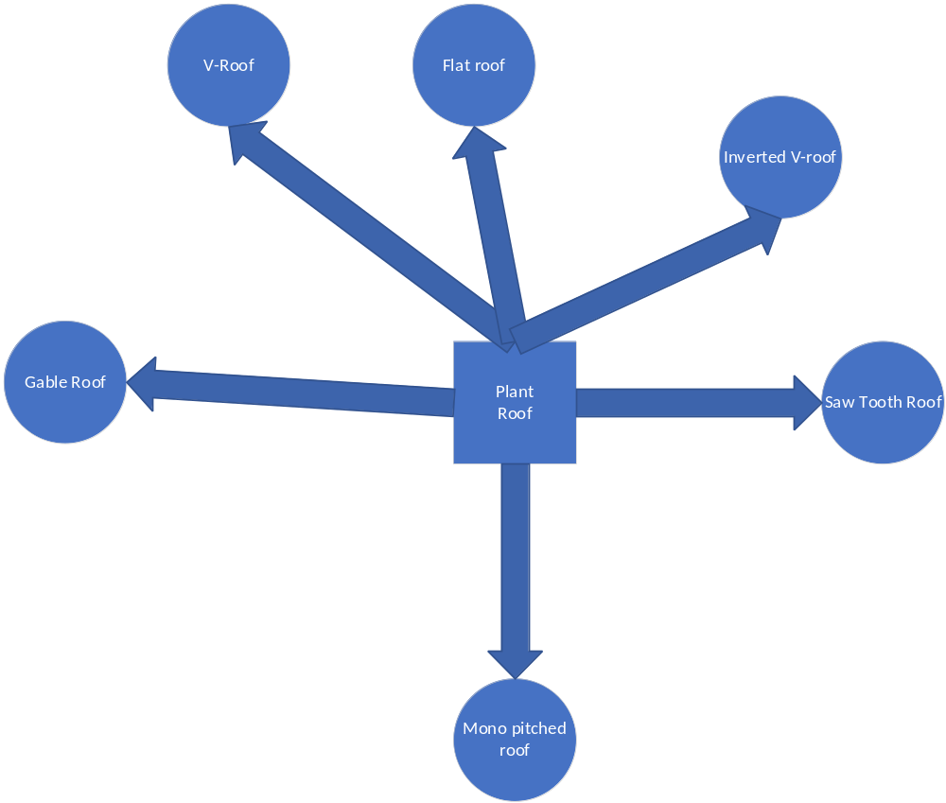

  - Plant Layout Phases

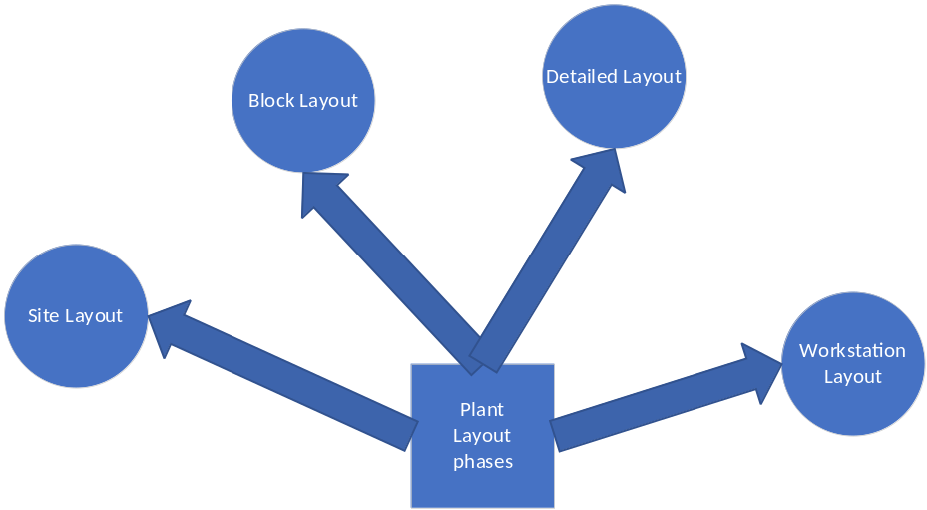

  - Systematic Layout Planning

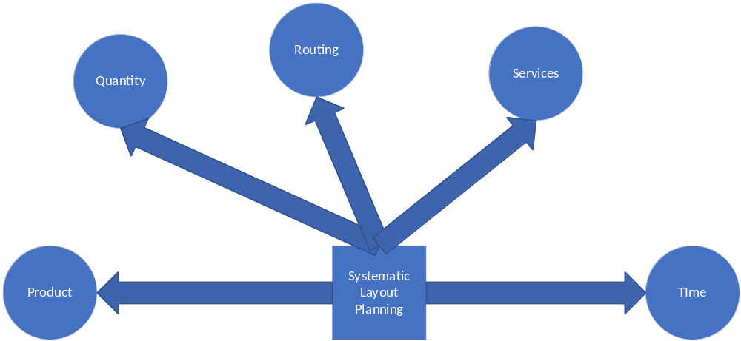

  - Capacity Planning

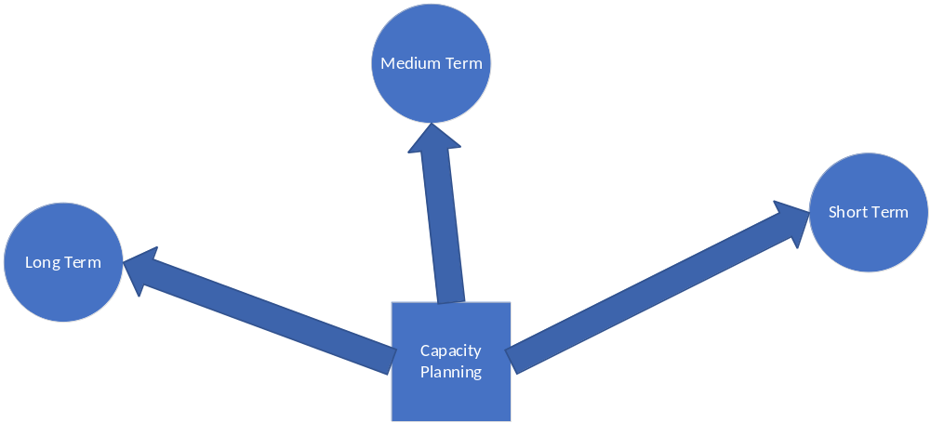

  - Capacity Planning Strategy

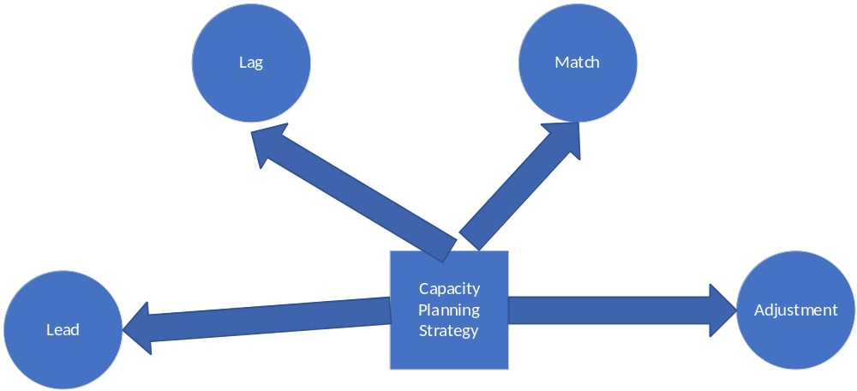

  - Capacity Planning Factors

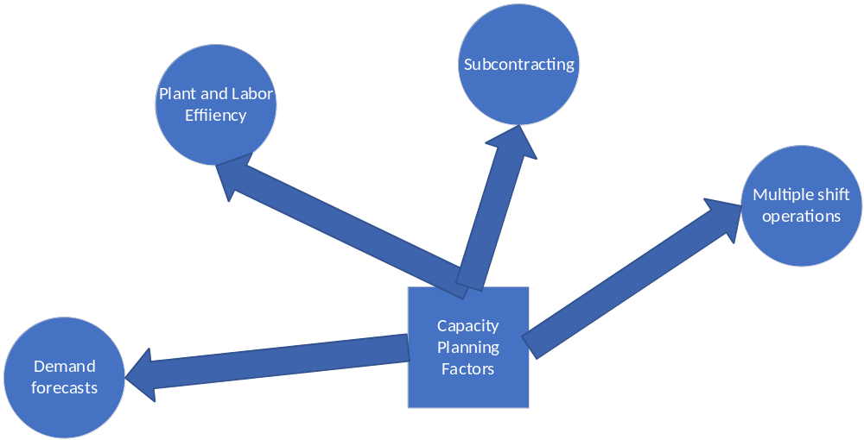

  - Rough Cut Planning

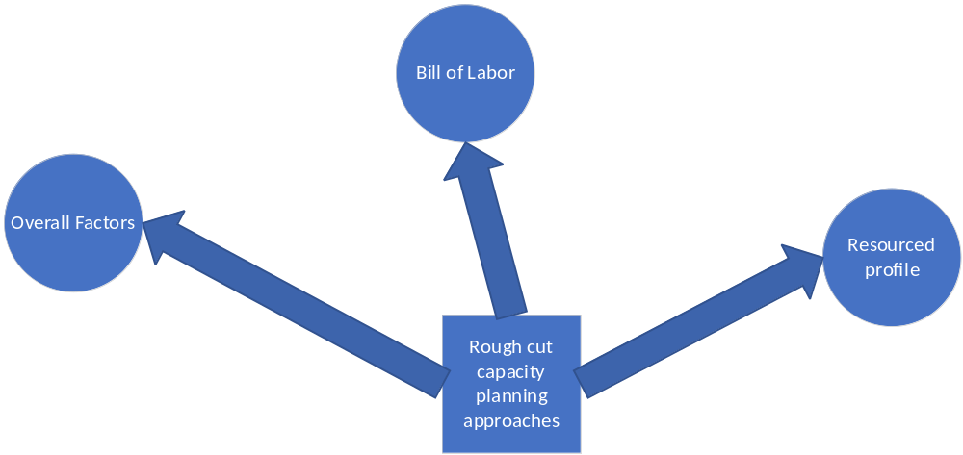

  - Capacity Measures

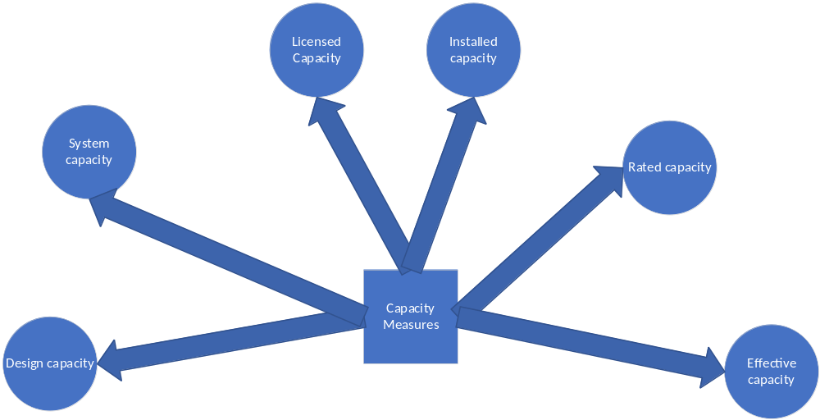

  - Machine Capacity Assessment

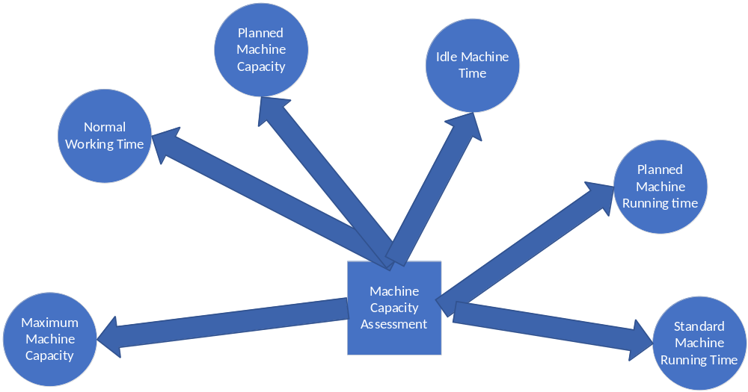

  - Capacity Planning Load
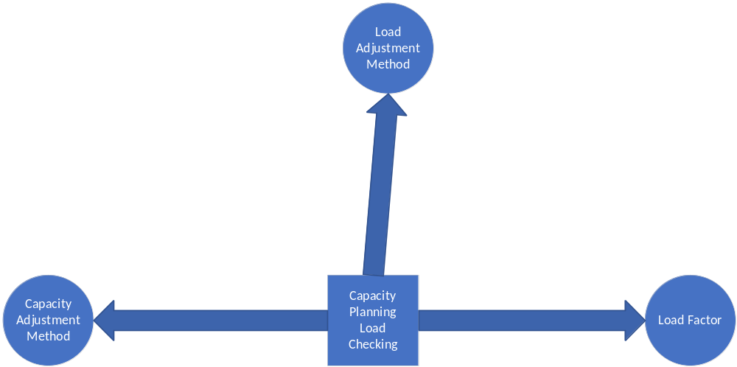

  - Aggregate Planning Inputs

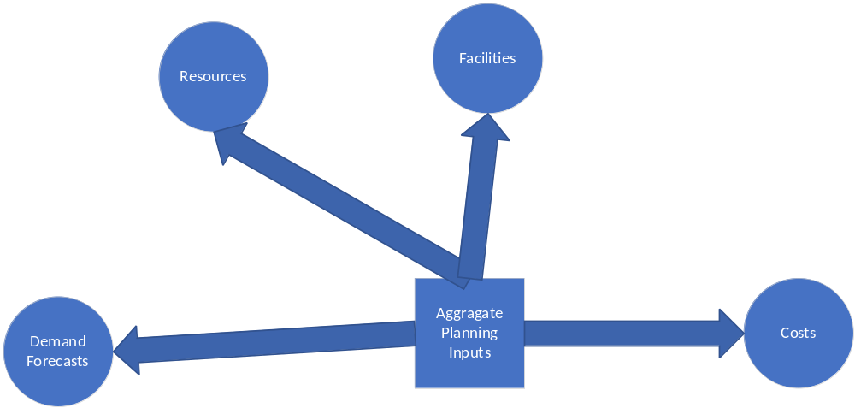

  - Aggregate Planning Strategies

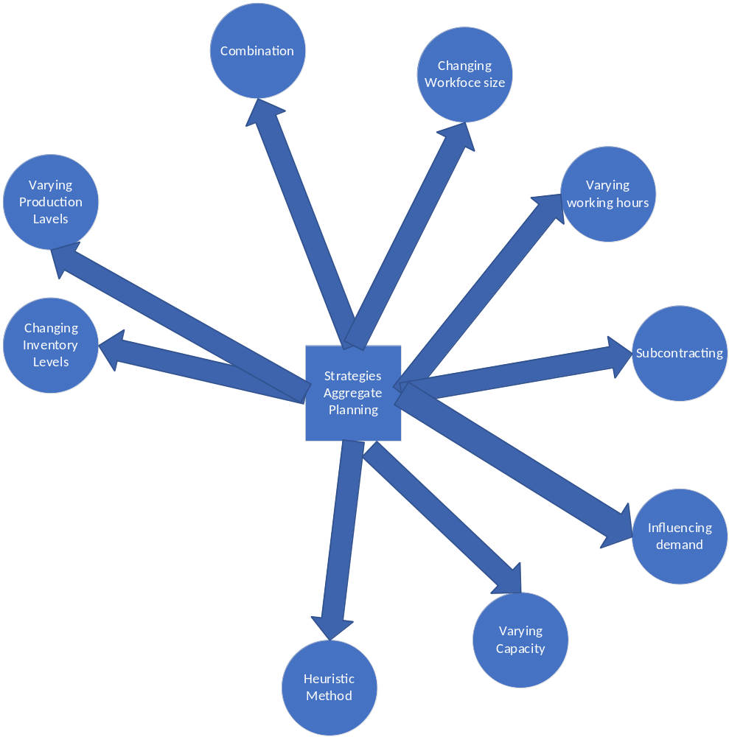

  - Routing

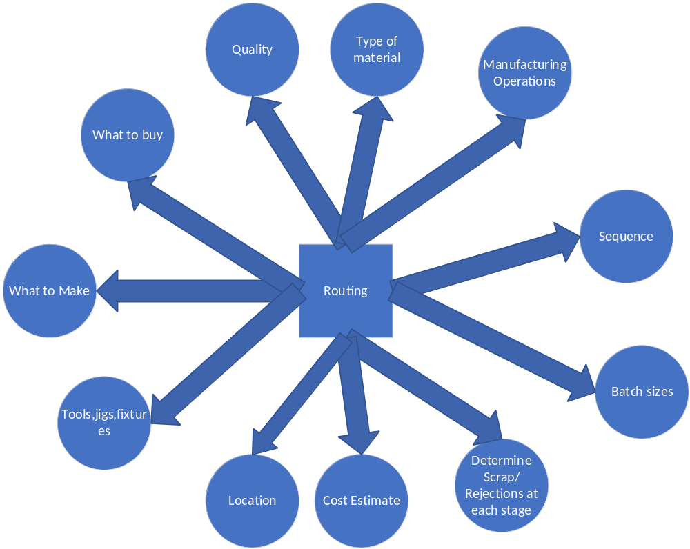

  - Route Sheet

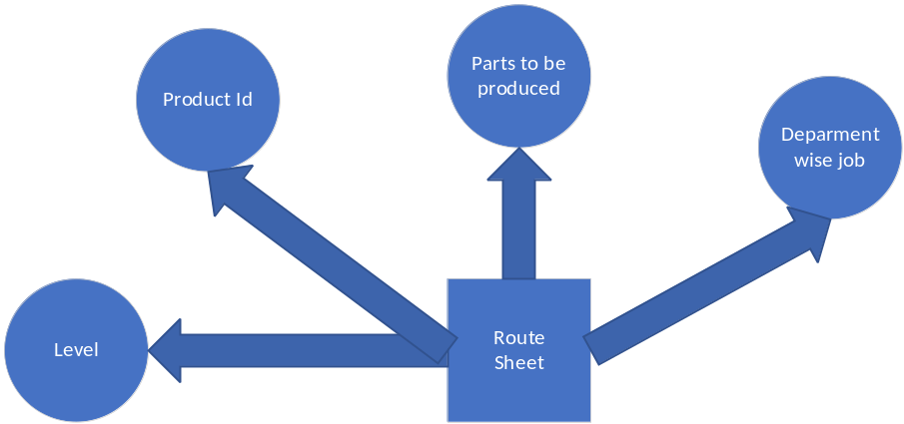

  - Route Card

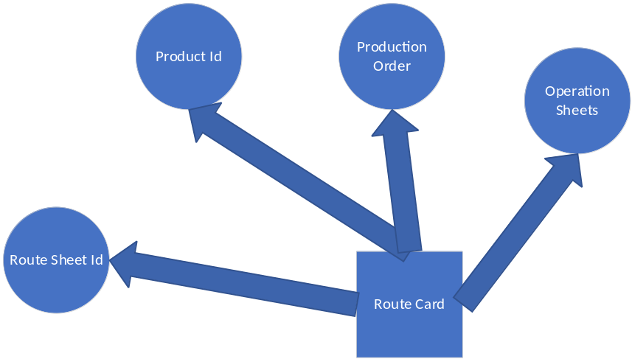

  - Scheduling Levels

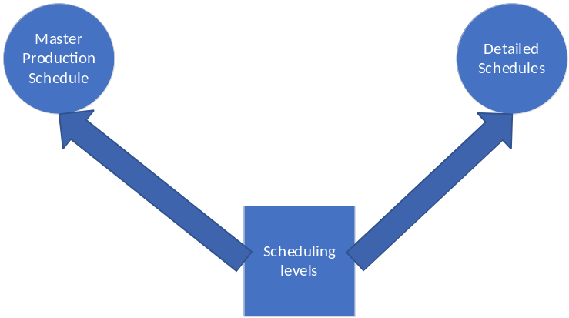

  - Detailed Schedules

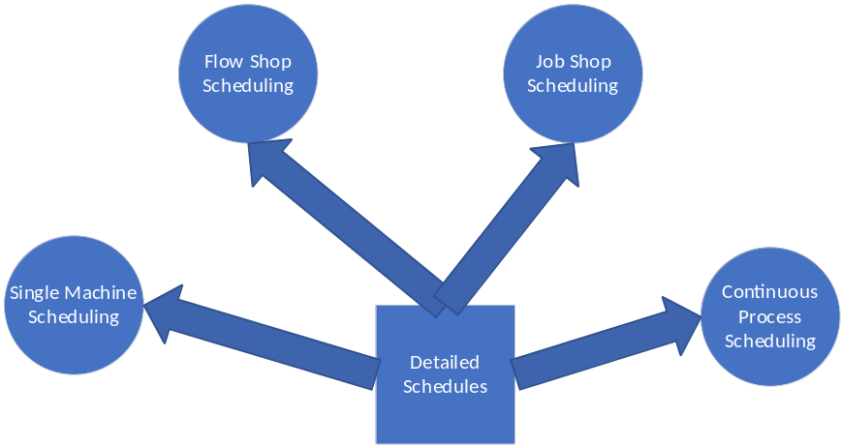

  - Scheduling Issues

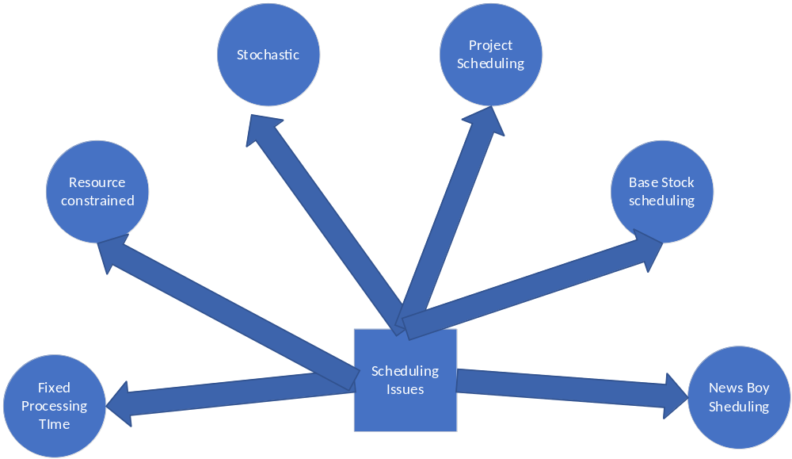

  - Manufacturing Lead Time
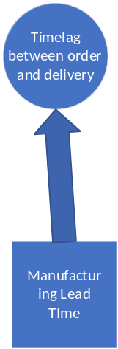

  - Loading

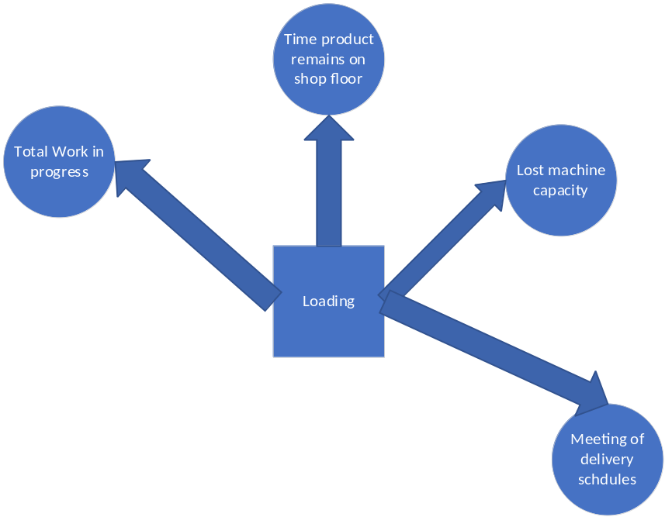

  - Appropriate Machine Choice

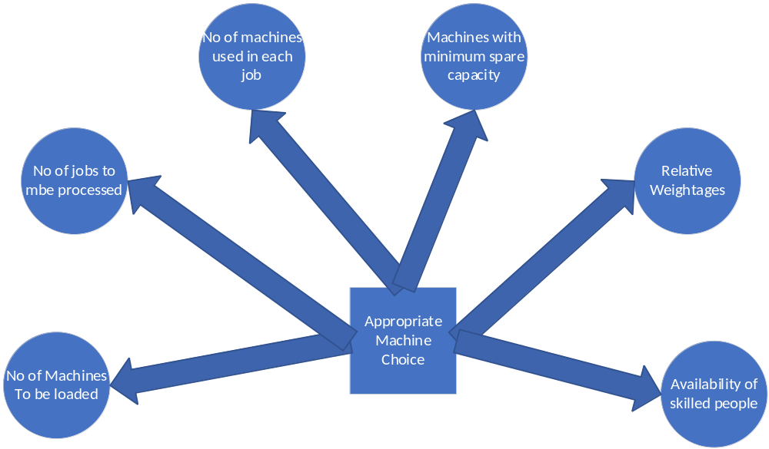

  - Priority Sequencing

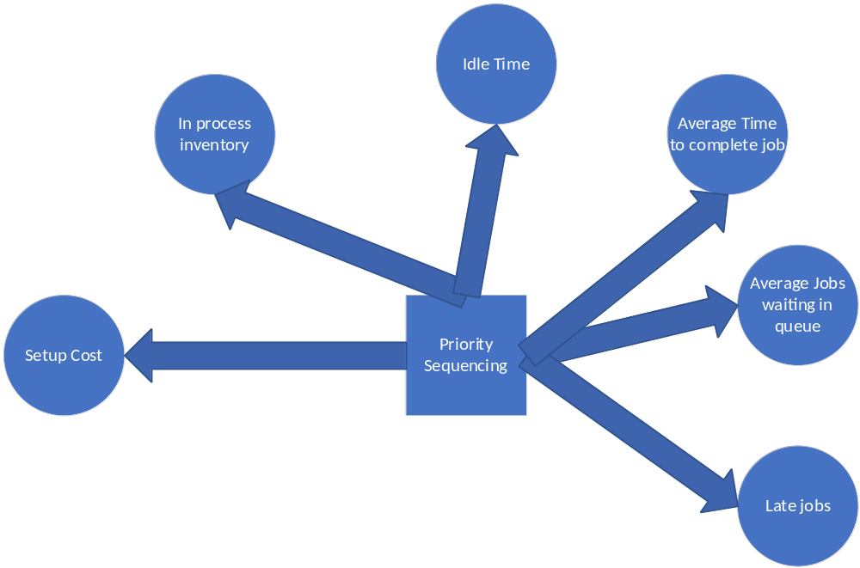

  - Master Production Schedule

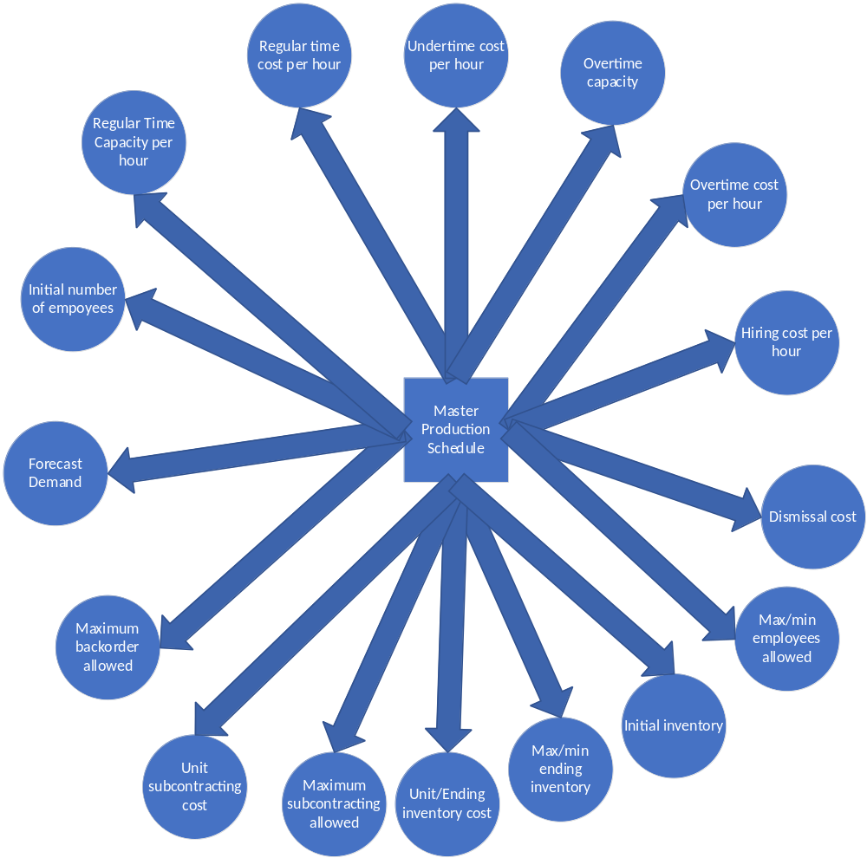

  - Master Production Schedules Inputs

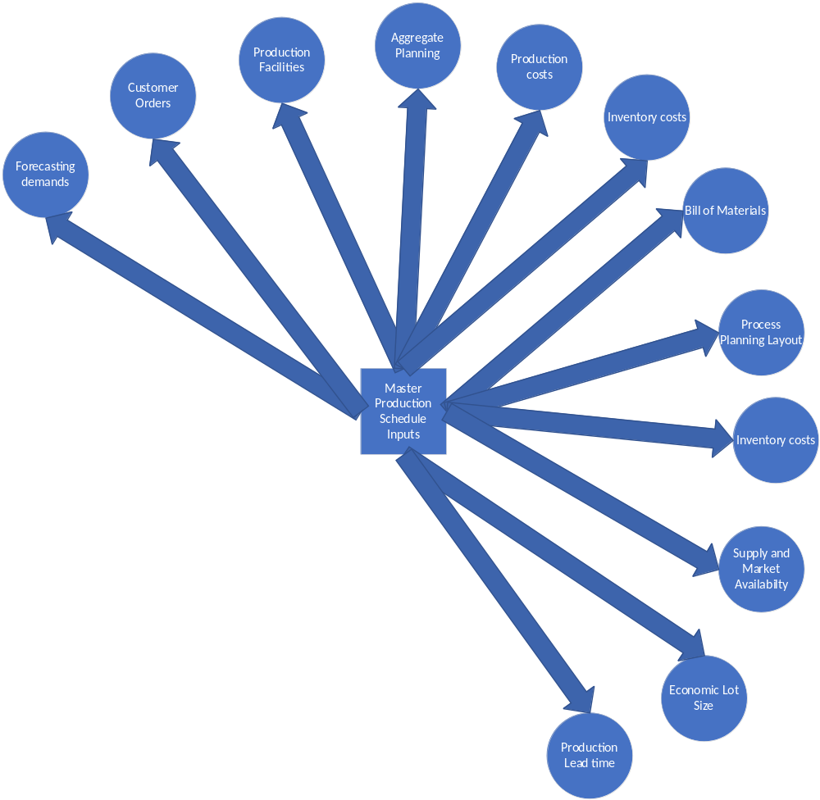

  - Material Requirement Planning

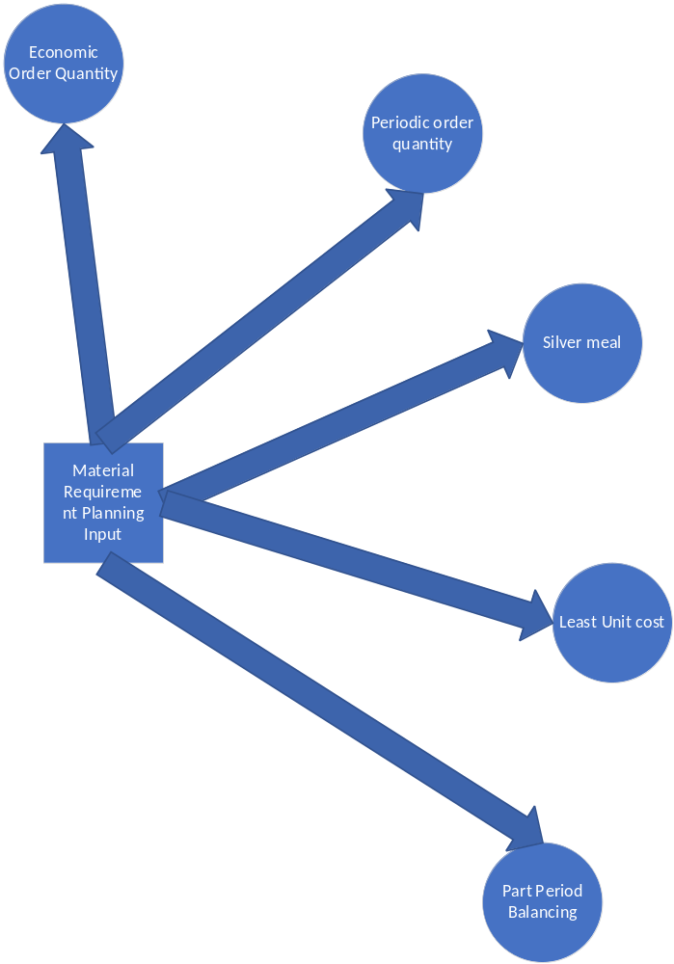

  - Scheduling Types

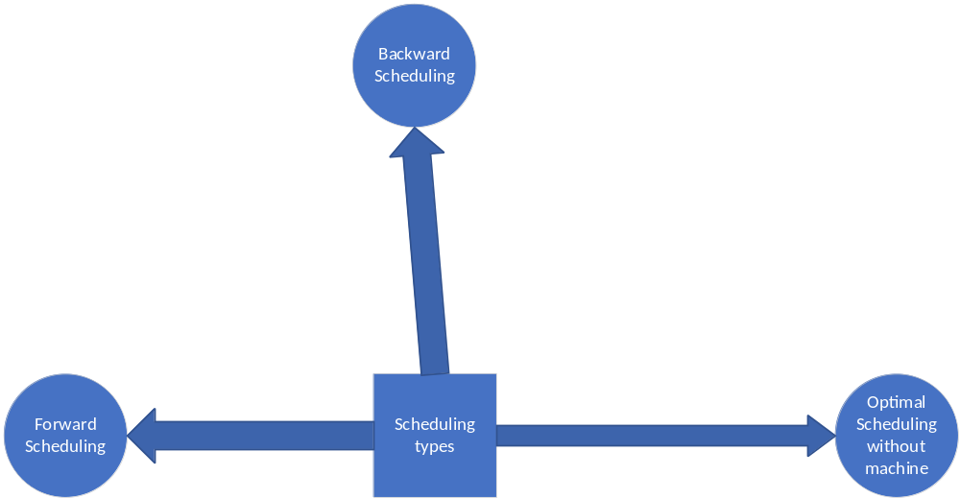

  - Master Production Schedule Issues

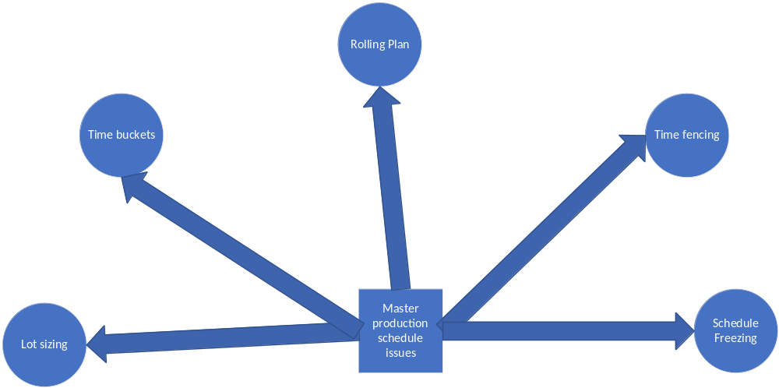

  - Production Sequencing

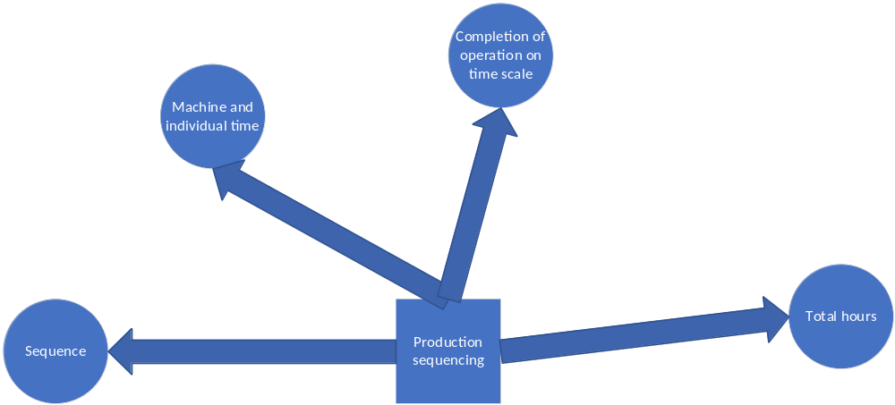

  - Line Balancing

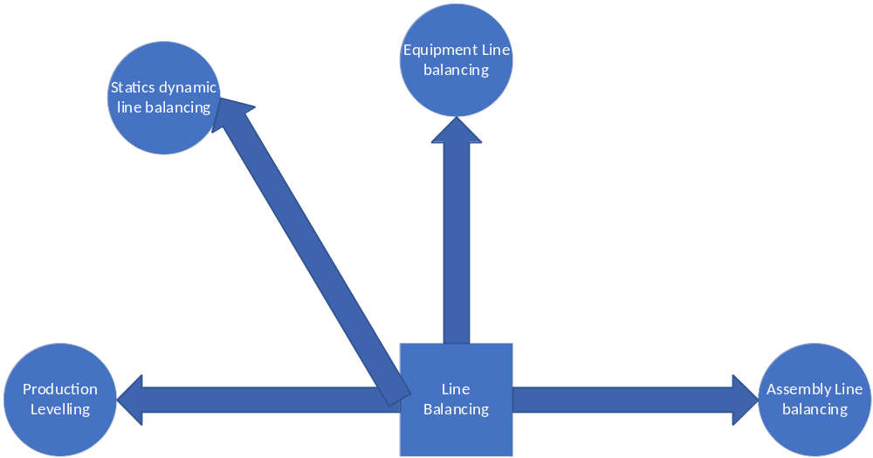

  - Machine Interference

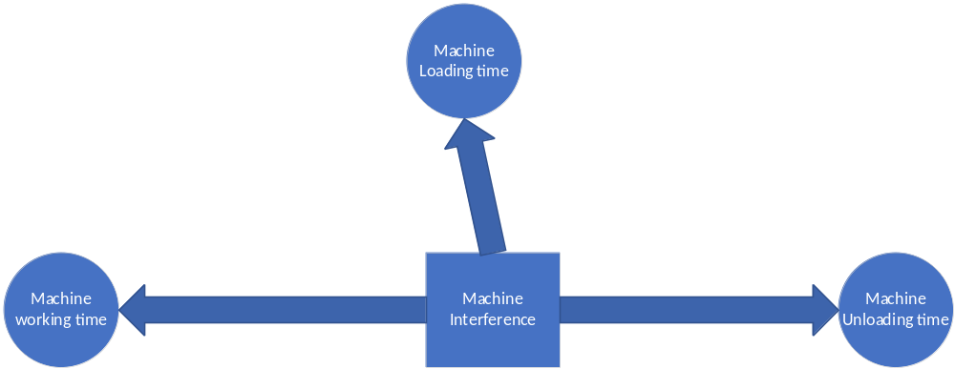

  - Record Operational Timings

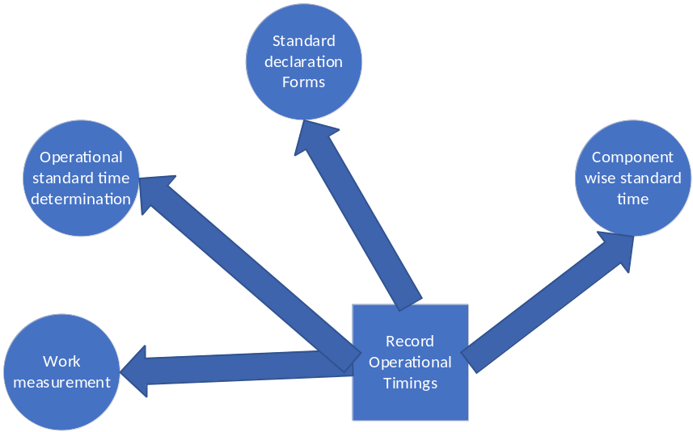

  - Production planning and scheduling formats

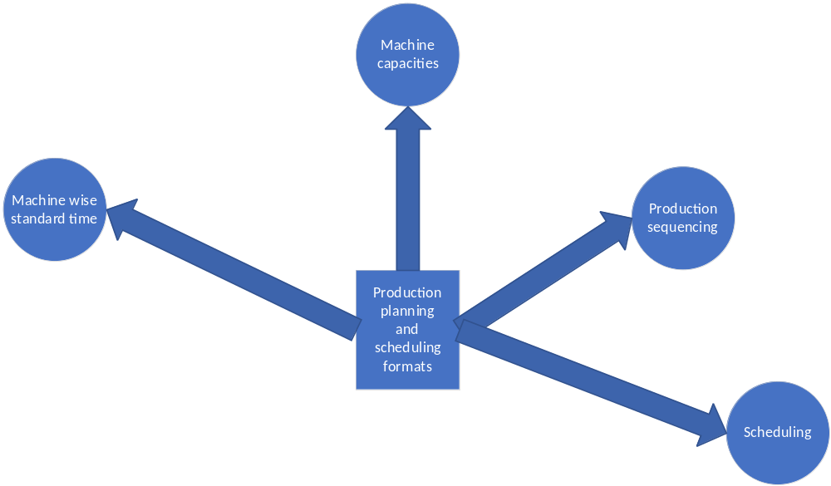

  - Progress Control formats

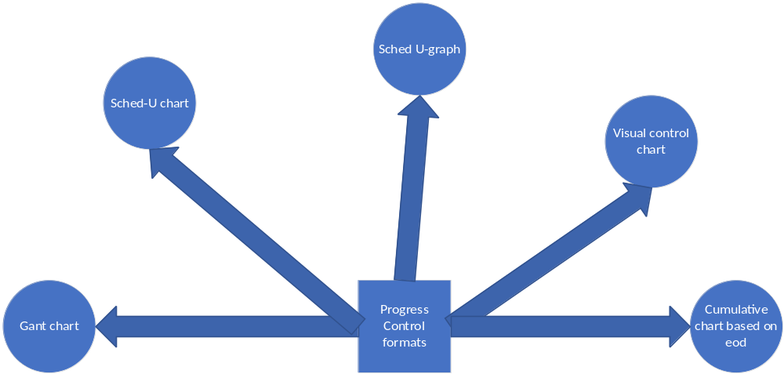

  - Componentwise operational timings
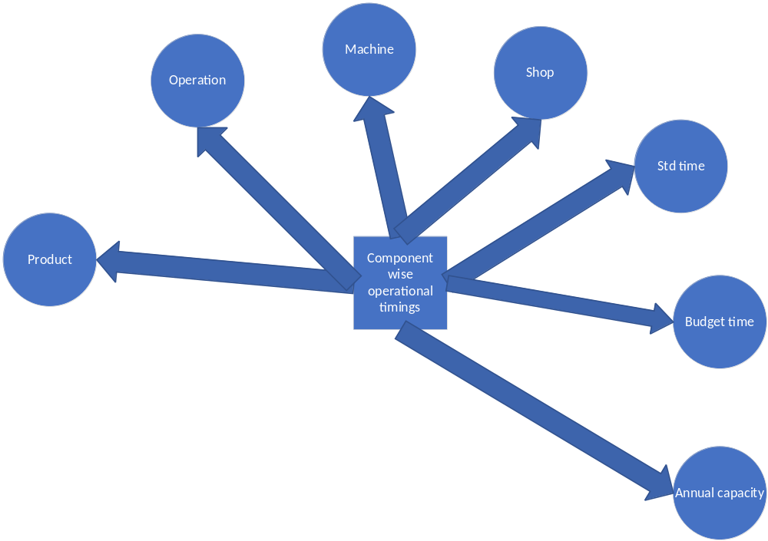
  - Machinewise operational timings

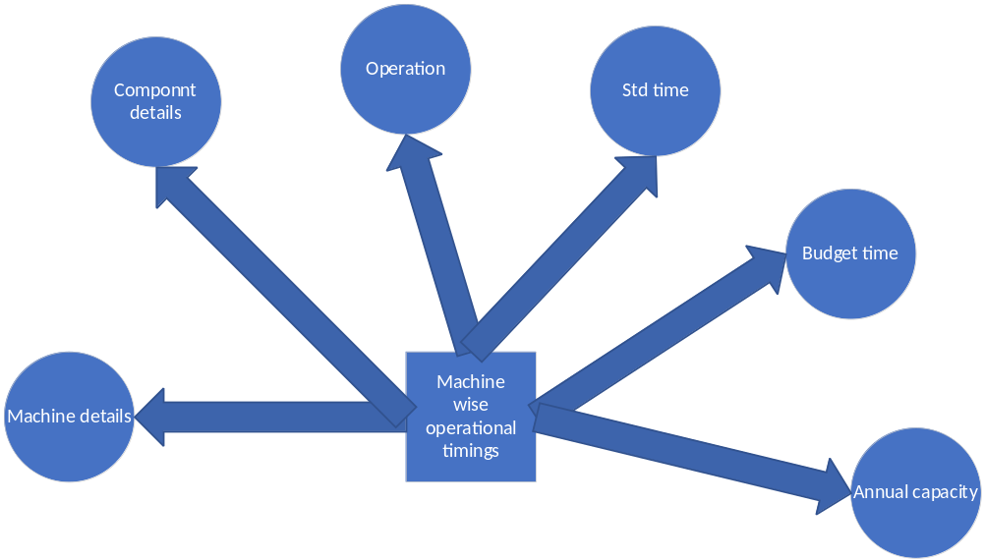

  - Machine capacities

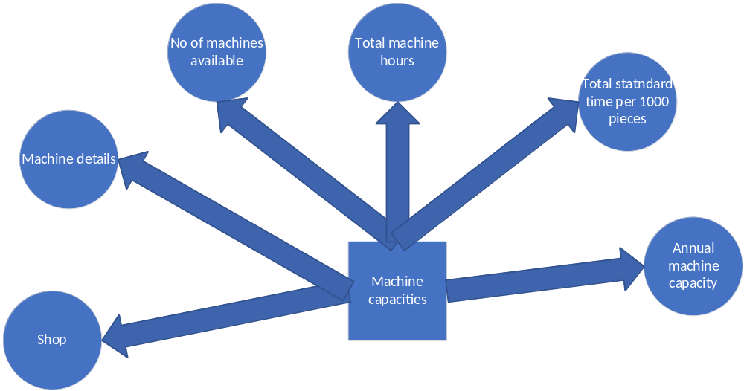

  - Process Planning layouts

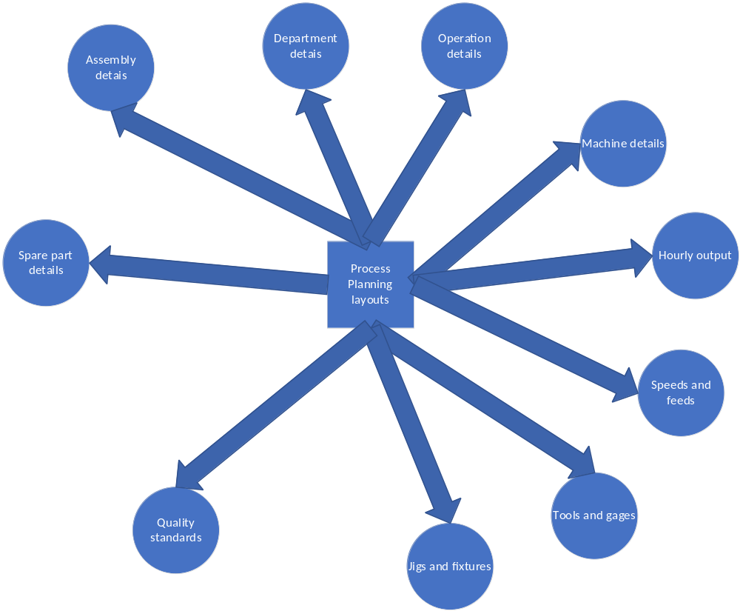

  - Route Sheet
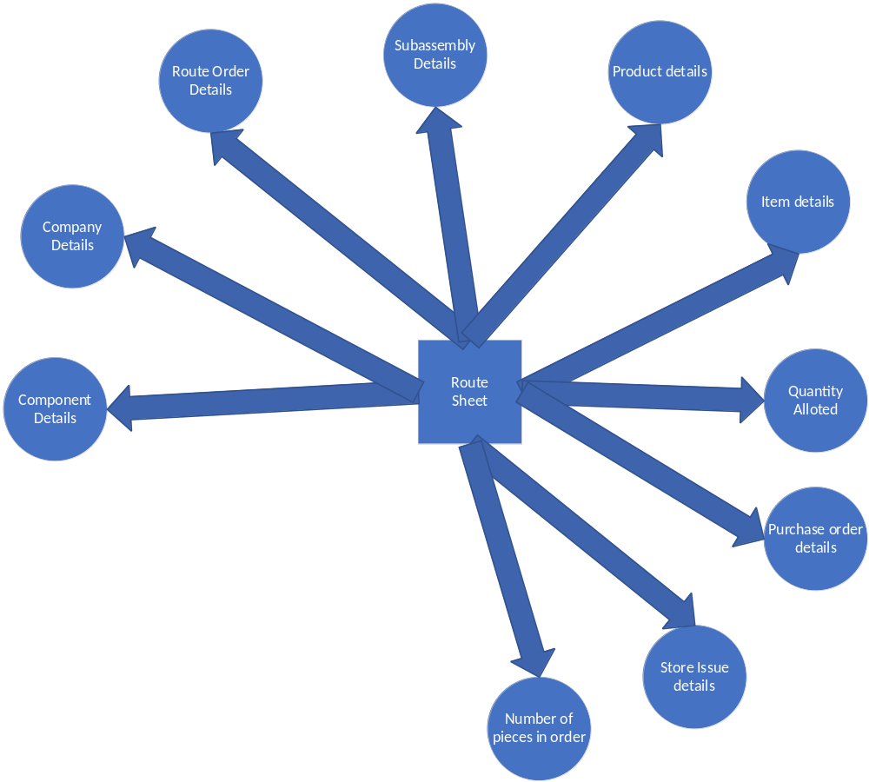

  - Job Order
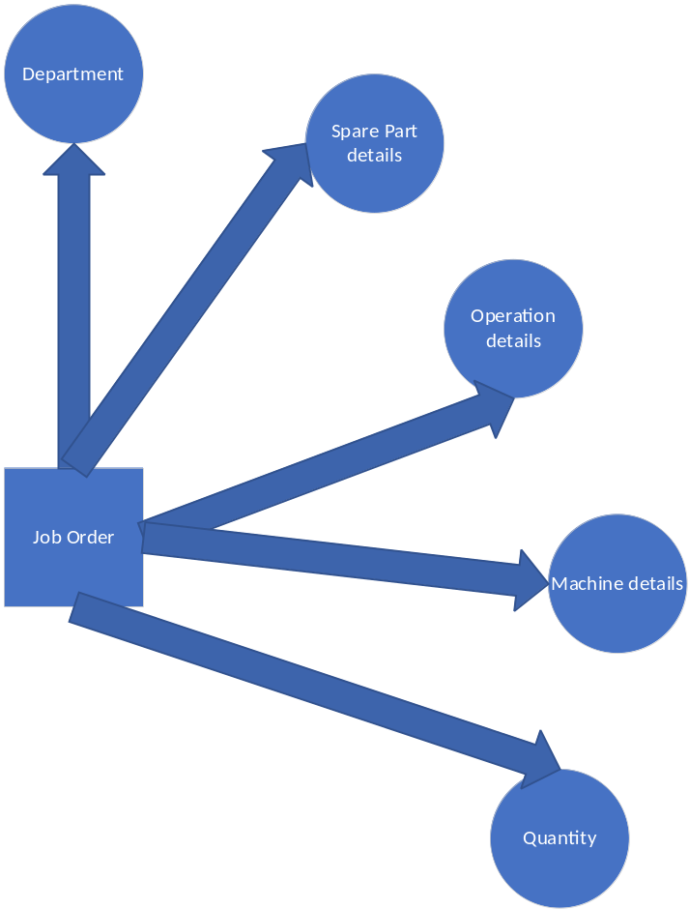

  - Facilities Maintenance Order

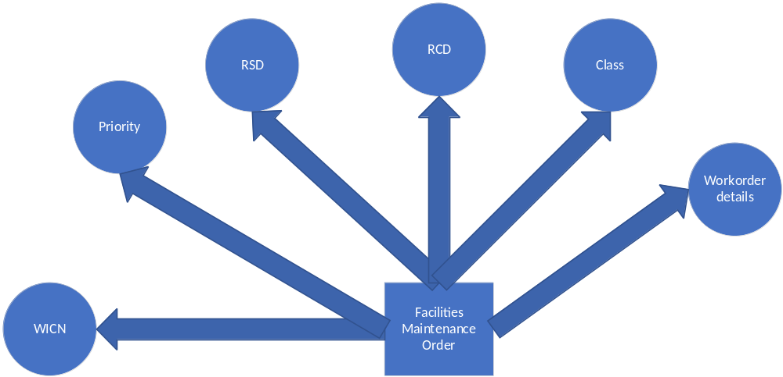
  - Material Warrant Raw Material
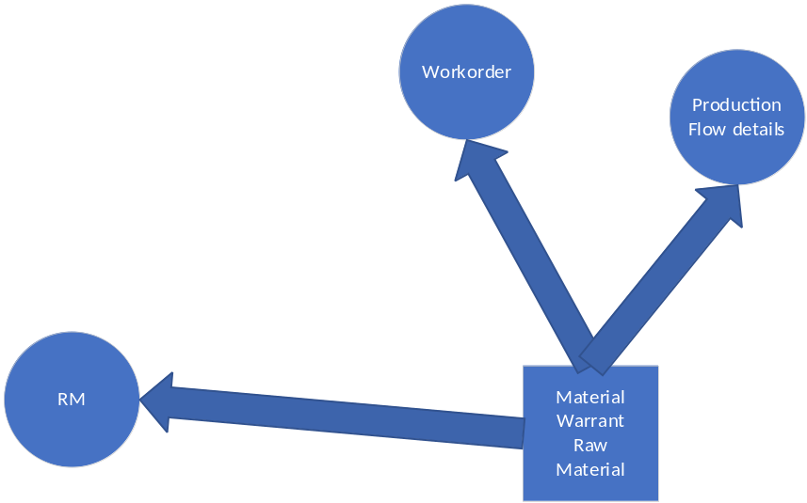

  - Material Warrant/General Supplies

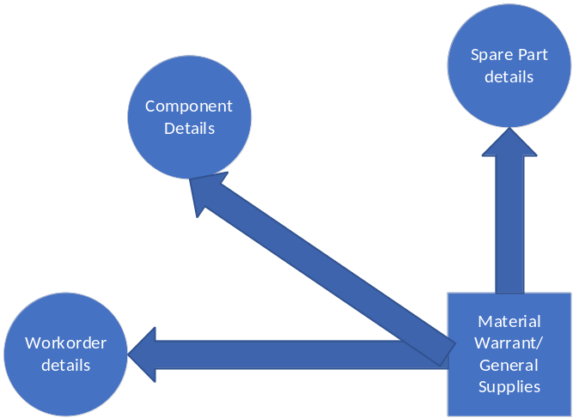

  - Time Ticket
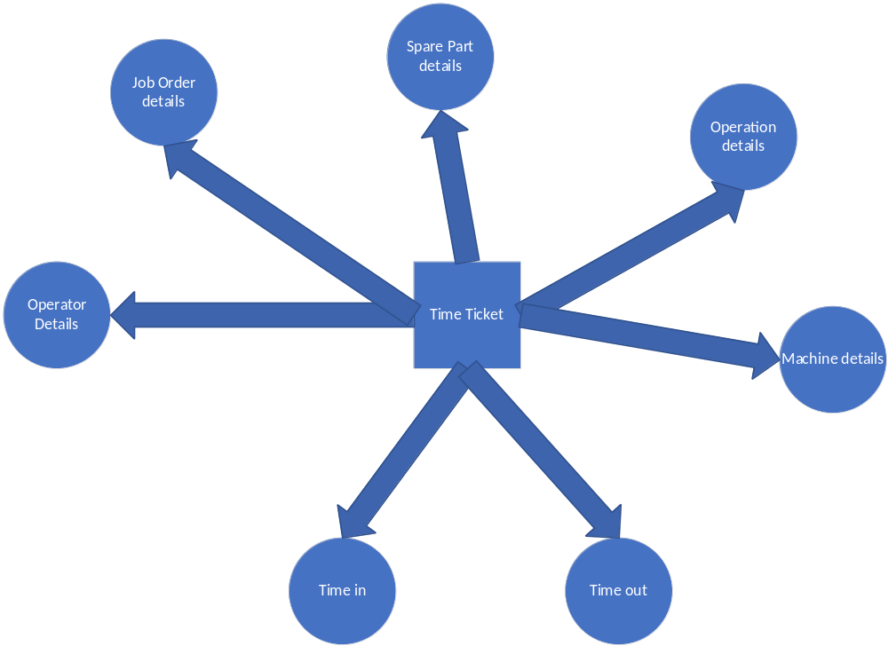

  - Move Order

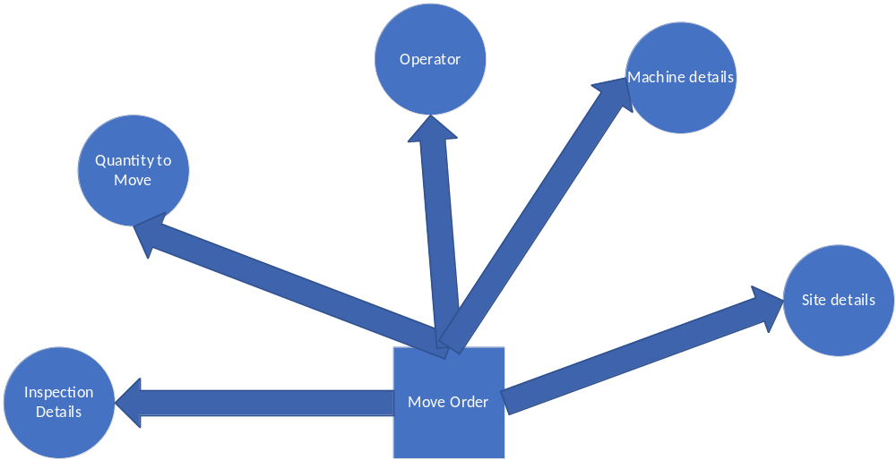

  - Inspection Order

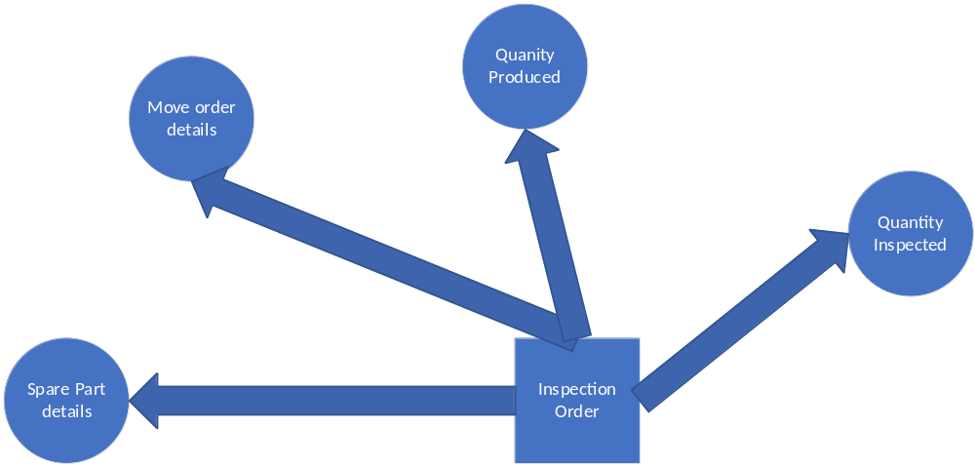

  - Indent Request
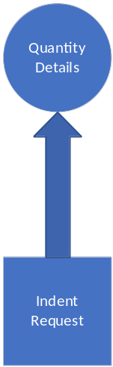

- Application

Sr No | Column | Column Description
1. | Id | Application Id
2. | Application Date | Application Date
3. | Budget | Budget
4. | Counter Party | Party Popup
5. | Target End Date | Target Date
6. | Rate of Interest | Interest Rate
7. | Tenor | Tenor
8. | Net Asset | Net Worth
9. | Budget Capital Type | Popup

- Jobcard
Sr No | Column Name | Description
1. | Jobcard Id | Id
2. | Transaction Date | Transaction Date
3. | Jobcard Date | Jobcard Date
4. | Job | Job Popup
5. | Supervisor Id | Supervisor Popup
6. | Production Plan Serial No | Plan Serial No
7. | World | World
8. | Country | Country
9. | State | State
10. | Suburb | Suburb

- Route Sheet

Sr No | Column Name | Description
1. | Id | Id
2. | Transaction Date | Transaction Date
3. | Item Id | Popup
4. | Item Serial No | Item Serial No
5. | Quantity to be produced | Quantity to be produced

Sr No | Column Name | Description
1. | Id | Id
2. | Operation Id | Popup
3. | Equipment Id | Popup
4. | Tool Id | Popup

- Route Card
Sr No | Column Name | Description
1. | Id | Id
2. | Transaction Date | Transaction Date
3. | Application Id | Popup
4. | Jobcard Id | Popup
5. | Product Id | Popup
6. | Route Sheet Id | Popup

Sr No | Column Name | Description
1. | Id | Id
2. | Process Id | Popup
3. | Start Date | Date
4. | End Date | Date
5. | Production Unit Id | Popup
6. | Rejection Unit Id | Popup
7. | Reason | Reason
8. | Accepted Unit Id | Popup

- Capacity Planning
  - Demand Forecasts
Sr No | Column Name | Description
1. | Id | Id
2. | Transaction Date | Transaction Date
3. | Jobcard Id | Popup
4. | Application Id | Popup
5. | Revenue Amount | Amount
6. | Facility Id | Popup
7. | Inspection Id | Popup
8. | Roof Type | Popup
9. | Warrant Id | Popup
10. | Schedule Type | Popup
11. | Schedule Issue | Popup
12. | Term | Popup
13. | Strategy | Popup
14. | Rough Cut Planning Type | Popup
15. | Capacity Measure | Popup
16. | Equilibrium Pricing Type | Popup
17. | Run Type | Popup e,g Short Run ,Long Run
18. | Forecast Approach | Popup e.g Evolutionary ,Substitute,Growth Curve,Opinion Poll,Sales Experience,Vicarious
19. | Forecasting Model | Popup
20. | Manufacturing System Type | Popup
21. | Land | Popup
22. | Lot | Popup
23. | Block | Popup
24. | World | World
24. | Country | Country
25. | State | State
26. | Suburb | Suburb

Sr No | Column Name | Description
1. | Id | Id
2. | Machine Id | Popup
3. | Route Card | Popup
4. | Sequence | Sequence
5. | Employee Id | Popup
6. | Time In | Time
7. | Time Out | Time
8. | Item Id | Popup
9. | Quantity | Quantity
10. | Price | Price
11. | Quantity | Quantity
12. | Demand Forecast Header Id | Demand Forecast Header Id
13. | Machine Loading TIme | Time
14. | Machine Unloading Time | Time
15. | Machine Working Time | Time
16. | Maximum Machine Capacity | Maximum Machine Capacity
17. | Normal Working Time | Normal Working Time
18. | Planned Machine Capacity | Planned Machine Capacity
19. | Idle Time | Idle Time
20. | Planned Machine Working Time | Planned Machine Working Time
21. | Standard Machine Working Time | Standard Machine Working Time
22. | Sequence Rule | Popup
23 | Machine Choice Type | Popup
24. | Fuel Availability Date | Date
25. | Existence Of Pipe | Y or N
26. | QualityId | Popup
27. | Fuel Cost | Fuel Cost
28. | Electrical System Id | Popup
29. | Water Connection Id | Popup

Process
On Input
Credit Demand Forecast Receivables
On Authorise
Debit Demand Forecast Receivables
Credit Demand Forecast Purchase
Credit Demand Forecast Payables
Debit Demand Forecast Sales
On Settle
Debit Demand Forecast Purchase
Debit Demand Forecast Payables
Credit Demand Forecast Sales
On PURCHASE/SALES/PAYABLES AUTHORISE
Update Reorder Quantity
Validate Min
Validate Max
Validate Reorder Quantity
Validate Reorder Level
Validate Demand Rate
Validate Demand Rate Cumulative Type
Validate Lead Time
Validate Lead Time Cumulative
Validate Cycle Stock
Validate Safety Stock
Validate Reorder Point
Validate Average Stock On Hand
Validate Inventory Reduction
Validate Stockout

Output
Materials Planning Reports
Weighted Average

  - Plant and Labor Efficiency
Sr No | Column Name | Description
1. | Id | Id
2. | Transaction Date | Transaction Date
3. | Plant Layout Id | Popup
4. | Jobcard Id | Popup
5. | Application Id | Popup
6. | Revenue Amount | Amount
7. | Plant Efficiency Type | Popup
8. | Facility Id | Popup
9. | Run Type | Popup e.g Short Run/Long Run
10. | Inspection Id | Popup
11. | Roof Type | Popup
12. | Warrant Id | Popup
13. | Schedule Type | Popup
14. | Schedule Issue | Popup
15. | Term | Popup
16. | Strategy | Popup
17. | Capacity Measure | Popup
18. | Equilibrium Pricing Type | Popup
19. | Plant Layout Type | Popup
20. | Plant Layout Phase | Popup
21. | Plant Layout Pattern | Popup
22. | Manufacturing System Type | Popup
23. | Land | Popup
24. | Lot | Popup
25. | Block | Popups
26. | World | World
27. | Country | Country
28. | State | State
29. | Suburb | Suburb

Sr No | Column Name | Description
1. | Id | Id
2. | Machine Id | Popup
3. | Route Card Id | Popup
4. | Sequence | Sequence
5. | Employee Id | Popup
6. | Time In | Time
7. | Time Out | Time
8. | Item Id | Popup
9. | Quantity | Quantity
11. | Price | Price
12. | Quantity | Quantity
13. | Plant Header Id | Plant Header Id
14. | Labor Efficiency Type | Popup
15. | Maximum Machine Capacity | Maximum Machine Capacity
16. | Normal Working Time | Normal Working Time
17. | Planned Machine Capacity | Planned Machine Capacity
18. | Idle Time | Idle Time
19. | Planned Machine Working Time | Planned Machine Working Time
20. | Standard Machine Working Time | Standard Machine Working Time
21. | Sequence Rule | Popup
22. | Machine Choice Type | Popup
19. | Machine Loading Time | Time
20. | Machine Unloading Time | Time
21. | Machine Working Time | Time
22. | Fuel Availability Date | Date
23. | Existence Of Pipe | Y or N
24. | QualityId | Popup
25. | Fuel Cost | Fuel Cost
26. | Electrical System Id | Popup
27. | Water Connection Id | Popup

Process
On Input
Credit Plant and Labor Receivables with Revenue Amount
On Authorise
Debit Plant and Labor Receivables
Credit Plant and Labor Purchase
Credit Plant and Labor Payables
Debit Plant and Labor Sales
On Settle
Debit Plant and Labor Purchase
Debit Plant and Labor Payables
Credit Plant and Labor Sales

On PURCHASE/SALES/PAYABLES AUTHORISE
Update Reorder Quantity
Validate Min
Validate Max
Validate Reorder Quantity
Validate Reorder Level
Validate Demand Rate
Validate Demand Rate Cumulative Type
Validate Lead Time
Validate Lead Time Cumulative
Validate Cycle Stock
Validate Safety Stock
Validate Reorder Point
Validate Average Stock On Hand
Validate Inventory Reduction
Validate Stockout

Output
Materials Planning Reports
Weighted Average

  - Subcontracting
Sr No | Column Name | Description
1. | Id | Id
2. | Transaction Date | Transaction Date
3. | Subcontract Id | Popup
4. | Jobcard Id | Popup
5. | Application Id | Popup
6. | Revenue Amount | Amount
7. | Plant Efficiency Type | Popup
8. | Facility Id | Popup
9. | Run type | Popup
10. | Inspection Id | Popup
11. | Roof Type | Popup
12. | Warrant Id | Popup
13. | Schedule Type | Popup
14. | Schedule Issue | Popup
15. | Term | Popup
16. | Strategy | Popup
17. | Contract Start Date | Date
18. | Contact End Date | Date
19. | Land | Popup
20. | Lot | Popup
21. | Block | Popup
22. | Capacity Measure Id | Popup
23. | Equilibrium Pricing Type | Popup
24. | Machine Loading Time | Time
25. | Machine Unloading Time | Time
26. | Machine Working Time | Time
27. | Manufacturing System Type | Popups
28. | Land | Popup
29 | Lot | Popup
30. | Block | Popup
31. | World | World
32. | Country | Country
33. | State | State
34. | Suburb | Suburb

Sr No | Column Name | Description
1. | Id | Id
2. | Machine Id | Popup
3. | Plant Id | Sequence
4. | Employee Id | Popup
5. | Time In | Time
6. | Time Out | Time
7. | Item Id | Popup
8. | Quantity | Quantity
9. | Price | Price
10. | Quantity | Quantity
11. | Subcontract Header Id | Plant Header Id
12. | Maximum Machine Capacity | Maximum Machine Capacity
13. | Normal Working Time | Normal Working Time
14. | Planned Machine Capacity | Planned Machine Capacity
15. | Idle Time | Idle Time
16. | Planned Machine Working Time | Planned Machine Working Time
17. | Standard Machine Working Time | Standard Machine Working Time
18. | Sequence Rule | Popup
19. | Machine Choice Type | Popup
20. | Fuel Availability Date | Date
21. | Existence Of Pipe | Y or N
22. | QualityId | Popup
23. | Fuel Cost | Fuel Cost
24. | Electrical System Id | Popup
25. | Water Connection Id | Popup

Process
On Input
Credit Subcontract Receivables with Revenue Amount
On Authorise
Debit Subcontract Receivables
Credit Subcontract Purchase
Credit Subcontract Payables
Debit Subcontract Sales
On Settle
Debit Subcontract Purchase
Debit Subcontract Payables
Credit Subcontract Sales
On PURCHASE/SALES/PAYABLES AUTHORISE
Update Reorder Quantity
Validate Min
Validate Max
Validate Reorder Quantity
Validate Reorder Level
Validate Demand Rate
Validate Demand Rate Cumulative Type
Validate Lead Time
Validate Lead Time Cumulative
Validate Cycle Stock
Validate Safety Stock
Validate Reorder Point
Validate Average Stock On Hand
Validate Inventory Reduction
Validate Stockout

Output
Materials Planning Reports
Weighted Average

  - Multiple Shift

Sr No | Column Name | Description
1. | Id | Id
2. | Transaction Date | Transaction Date
3. | Jobcard Id | Popup
4. | Application Id | Popup
5. | Revenue Amount | Amount
6. | Facility Id | Popup
7. | Run type | Popup
8. | Inspection Id | Popup
9. | Roof Type | Popup
10. | Warrant Id | Popup
11. | Schedule Type | Popup
12. | Schedule Issue | Popup
13. | Term | Popup
14. | Strategy | Popup
15. | Rough Cut Planning Type | Popup
16. | Equilibrium Pricing Type | Popup
17. | Manufacturing System Type | Popup
18. | Land | Popup
19. | Lot | Popup
20. | Block | Popupss
21. | World | World
22. | Country | Country
23. | State | State
24. | Suburb | Suburb

Sr No | Column Name | Description
1. | Id | Id
2. | Machine Id | Popup
3. | Route Card Id | Popup
4. | Sequence | Sequence
5. | Employee Id | Popup
6. | Time In | Time
7. | Time Out | Time
8. | Item Id | Popup
9. | Quantity | Quantity
10. | Price | Price
12. | Quantity | Quantity
13. | Multiple Shift Header Id | Demand Forecast Header Id
14. | Shift Id | Popup
15. | Machine Loading Time | Time
16. | Machine Unloading Time | Time
17. | Machine Working Time | Time
18. | Maximum Machine Capacity | Maximum Machine Capacity
19. | Normal Working Time | Normal Working Time
20. | Planned Machine Capacity | Planned Machine Capacity
21. | Idle Time | Idle Time
22. | Planned Machine Working Time | Planned Machine Working Time
23. | Standard Machine Working Time | Standard Machine Working Time
24. | Sequence Rule | Popup
25. | Machine Choice Type | Popup
26. | Fuel Availability Date | Date
27. | Existence Of Pipe | Y or N
28. | QualityId | Popup
29. | Fuel Cost | Fuel Cost
30. | Electrical System Id | Popup
31. | Water Connection Id | Popup

Process
On Input
Credit Multiple Shift Forecast Receivables
On Authorise
Debit Multiple Shift Receivables
Credit Multiple Shift Purchase
Credit Multiple Shift Payables
Debit Multiple Shift Sales
On Settle
Debit Multiple Shift Purchase
Debit Multiple Shift Payables
Credit Multiple Shift Sales
On PURCHASE/SALES/PAYABLES AUTHORISE
Update Reorder Quantity
Validate Min
Validate Max
Validate Reorder Quantity
Validate Reorder Level
Validate Demand Rate
Validate Demand Rate Cumulative Type
Validate Lead Time
Validate Lead Time Cumulative
Validate Cycle Stock
Validate Safety Stock
Validate Reorder Point
Validate Average Stock On Hand
Validate Inventory Reduction
Validate Stockout

Output
Materials Planning Reports
Weighted Average

- Aggregate Planning
  - Pricing Differentials and Promotions
Sr No | Column Name | Description
1. | Id | Id
2. | Transaction Date | Transaction Date
3. | Jobcard Id | Popup
4. | Application Id | Popup
5. | Revenue Amount | Amount
6. | Facility Id | Popup
7. | Run type | Popup
8. | Inspection Id | Popup
9. | Roof Type | Popup
10. | Warrant Id | Popup
11. | Schedule Type | Popup
12. | Schedule Issue | Popup
13. | Term | Popup
14. | Strategy | Popup
15. | Pricing Revenue Type | Discriminatory Pricing/ Flexible Pricing/Multiple Pricing/Variable Pricing
16. | Equilibrium Pricing Type | Popup
17. | Manufacturing System Type | Popup
18. | Land | Popup
19. | Lot | Popup
20. | Block | Popup
21. | World | World
22. | Country | Country
23. | State | State
24. | Suburb | Suburb

Sr No | Column Name | Description
1. | Id | Id
2. | Machine Id | Popup
3. | Route Card Id | Popup
4. | Sequence | Sequence
5. | Employee Id | Popup
6. | Time In | Time
7. | Time Out | Time
8. | Item Id | Popup
9. | Quantity | Quantity
10. | Price | Price
12. | Quantity | Quantity
14. | Shift Id | Popup
15. | Machine Loading Time | Time
16. | Machine Unloading Time | Time
17. | Machine Working Time | Time
18 | Maximum Machine Capacity | Maximum Machine Capacity
19. | Normal Working Time | Normal Working Time
20. | Planned Machine Capacity | Planned Machine Capacity
21. | Idle Time | Idle Time
22. | Planned Machine Working Time | Planned Machine Working Time
23. | Standard Machine Working Time | Standard Machine Working Time
24. | Sequence Rule | Popup
25. | Machine Choice Type | Popup
26. | Fuel Availability Date | Date
27. | Existence Of Pipe | Y or N
28. | QualityId | Popup
29. | Fuel Cost | Fuel Cost
30. | Electrical System Id | Popup
31. | Water Connection Id | Popup

Process
On Input
Credit Differentials Discriminatory Pricing/ Flexible Pricing/Multiple Pricing/Variable Pricing Receivables
On Authorise
Debit Differentials Discriminatory Pricing/ Flexible Pricing/Multiple Pricing/Variable Pricing Receivables

Credit Differentials Discriminatory Pricing/ Flexible Pricing/Multiple Pricing/Variable Pricing Purchase
Credit Differentials Discriminatory Pricing/ Flexible Pricing/Multiple Pricing/Variable Pricing Payables
Debit Differentials Discriminatory Pricing/ Flexible Pricing/Multiple Pricing/Variable Pricing Sales
On Settle
Debit Differentials Discriminatory Pricing/ Flexible Pricing/Multiple Pricing/Variable Pricing Purchase
Debit Differentials Discriminatory Pricing/ Flexible Pricing/Multiple Pricing/Variable Pricing Payables
Credit Differentials Discriminatory Pricing/ Flexible Pricing/Multiple Pricing/Variable Pricing Sales
On PURCHASE/SALES/PAYABLES AUTHORISE
Update Reorder Quantity
Validate Min
Validate Max
Validate Reorder Quantity
Validate Reorder Level
Validate Demand Rate
Validate Demand Rate Cumulative Type
Validate Lead Time
Validate Lead Time Cumulative
Validate Cycle Stock
Validate Safety Stock
Validate Reorder Point
Validate Average Stock On Hand
Validate Inventory Reduction
Validate Stockout

Output
Material Planning Report
Weighted Average

  - Back Ordering
Sr No | Column Name | Description
1. | Id | Id
2. | Transaction Date | Transaction Date
3. | Jobcard Id | Popup
4. | Application Id | Popup
5. | Revenue Amount | Amount
6. | Facility Id | Popup
7. | Run type | Popup
8. | Inspection Id | Popup
9. | Roof Type | Popup
10. | Warrant Id | Popup
11. | Schedule Type | Popup
12. | Schedule Issue | Popup
13. | Term | Popup
14. | Strategy | Popup
15. | Pricing Revenue Type | Discriminatory Pricing/ Flexible Pricing/Multiple Pricing/Variable Pricing
16. | Equilibrium Pricing Type | Popup
17. | Manufacturing System Type | Popup
18. | Land | Popup
19. | Lot | Popup
20. | Block | Popup
21. | World | World
22. | Country | Country
23. | State | State
24. | Suburb | Suburb

Sr No | Column Name | Description
1. | Id | Id
2. | Machine Id | Popup
3. | Route Card Id | Popup
4. | Sequence | Sequence
5. | Employee Id | Popup
6. | Time In | Time
7. | Time Out | Time
8. | Item Id | Popup
9. | Quantity | Quantity
10. | Price | Price
12. | Quantity | Quantity
13. | Out of stock date | Date
14. | Machine Loading Time | Time
15. | Machine Unloading Time | Time
16. | Machine Working Time | Time
17. | Maximum Machine Capacity | Maximum Machine Capacity
18. | Normal Working Time | Normal Working Time
19. | Planned Machine Capacity | Planned Machine Capacity
20. | Idle Time | Idle Time
21. | Planned Machine Working Time | Planned Machine Working Time
22. | Standard Machine Working Time | Standard Machine Working Time
23. | Sequence Rule | Popup
24. | Machine Choice Type | Popup
25. | Fuel Availability Date | Date
26. | Existence Of Pipe | Y or N
27. | QualityId | Popup
28. | Fuel Cost | Fuel Cost
29. | Electrical System Id | Popup
30. | Water Connection Id | Popup

Process
On Input
Credit Back Ordering Discriminatory Pricing/ Flexible Pricing/Multiple Pricing/Variable Pricing Receivables
On Authorise
Debit Back Ordering Discriminatory Pricing/ Flexible Pricing/Multiple Pricing/Variable Pricing Receivables

Credit Back Ordering Discriminatory Pricing/ Flexible Pricing/Multiple Pricing/Variable Pricing Purchase
Credit Back Ordering Discriminatory Pricing/ Flexible Pricing/Multiple Pricing/Variable Pricing Payables
Debit Back Ordering Discriminatory Pricing/ Flexible Pricing/Multiple Pricing/Variable Pricing Sales
On Settle
Debit Back Ordering Discriminatory Pricing/ Flexible Pricing/Multiple Pricing/Variable Pricing Purchase
Debit Back Ordering Discriminatory Pricing/ Flexible Pricing/Multiple Pricing/Variable Pricing Payables
Credit Back Ordering Discriminatory Pricing/ Flexible Pricing/Multiple Pricing/Variable Pricing Sales

On PURCHASE/SALES/PAYABLES AUTHORISE
Update Reorder Quantity
Validate Min
Validate Max
Validate Reorder Quantity
Validate Reorder Level
Validate Demand Rate
Validate Demand Rate Cumulative Type
Validate Lead Time
Validate Lead Time Cumulative
Validate Cycle Stock
Validate Safety Stock
Validate Reorder Point
Validate Average Stock On Hand
Validate Inventory Reduction
Validate Stockout

Output
Materials Planning Reports
Weighted Average

  - Generate Demand
Sr No | Column Name | Description
1. | Id | Id
2. | Transaction Date | Transaction Date
3. | Jobcard Id | Popup
4. | Application Id | Popup
5. | Revenue Amount | Amount
6. | Facility Id | Popup
7. | Run type | Popup
8. | Inspection Id | Popup
9. | Roof Type | Popup
10. | Warrant Id | Popup
11. | Schedule Type | Popup
12. | Schedule Issue | Popup
13. | Term | Popup
14. | Strategy | Popup
15. | Rough Cut Planning Type | Popup
16. | Capacity Measure | Popup
17. | Pricing Revenue Type | Discriminatory Pricing/ Flexible Pricing/Multiple Pricing/Variable Pricing
18. | Equilibrium Pricing Type | Popup
19. | Manufacturing System Type | Popup
20. | Land | Popup
21. | Lot | Popup
22. | Block | Popup
23. | World | World
24. | Country | Country
25. | State | State
26. | Suburb | Suburb

Sr No | Column Name | Description
1. | Id | Id
2. | Machine Id | Popup
3. | Route Card Id | Popup
4. | Sequence | Sequence
5. | Employee Id | Popup
6. | Time In | Time
7. | Time Out | Time
8. | Item Id | Popup
9. | Quantity | Quantity
11. | Price | Price
12. | Quantity | Quantity
13. | Demand Forecast Header Id | Demand Forecast Header Id
14. | Machine Loading Time | Time
15. | Machine Unloading Time | Time
16. | Machine Working Time | Time
17. | Maximum Machine Capacity | Maximum Machine Capacity
18. | Normal Working Time | Normal Working Time
19. | Planned Machine Capacity | Planned Machine Capacity
20. | Idle Time | Idle Time
21. | Planned Machine Working Time | Planned Machine Working Time
22. | Standard Machine Working Time | Standard Machine Working Time
23. | Sequence Rule | Popup
24. | Machine Choice Type | Popup
25. | Fuel Availability Date | Date
26. | Existence Of Pipe | Y or N
27. | QualityId | Popup
28. | Fuel Cost | Fuel Cost
29. | Electrical System Id | Popup
30. | Water Connection Id | Popup

Process
On Input
Credit Demand Forecast Discriminatory Pricing/ Flexible Pricing/Multiple Pricing/Variable Pricing Receivables
On Authorise
Debit Demand Forecast Discriminatory Pricing/ Flexible Pricing/Multiple Pricing/Variable Pricing Receivables

Credit Demand Forecast Discriminatory Pricing/ Flexible Pricing/Multiple Pricing/Variable Pricing Purchase
Credit Demand Forecast Discriminatory Pricing/ Flexible Pricing/Multiple Pricing/Variable Pricing Payables
Debit Demand Forecast Discriminatory Pricing/ Flexible Pricing/Multiple Pricing/Variable Pricing Sales
On Settle
Debit Demand Forecast Discriminatory Pricing/ Flexible Pricing/Multiple Pricing/Variable Pricing Purchase
Debit Demand Forecast Discriminatory Pricing/ Flexible Pricing/Multiple Pricing/Variable Pricing Payables
Credit Demand Forecast Discriminatory Pricing/ Flexible Pricing/Multiple Pricing/Variable Pricing Sales

On PURCHASE/SALES/PAYABLES AUTHORISE
Update Reorder Quantity
Validate Min
Validate Max
Validate Reorder Quantity
Validate Reorder Level
Validate Demand Rate
Validate Demand Rate Cumulative Type
Validate Lead Time
Validate Lead Time Cumulative
Validate Cycle Stock
Validate Safety Stock
Validate Reorder Point
Validate Average Stock On Hand
Validate Inventory Reduction
Validate Stockout

Output
Materials Planning Reports
Weighted Average

  - Seasonal Hiring
Sr No | Column Name | Description
1. | Id | Id
2. | Transaction Date | Transaction Date
3. | Jobcard Id | Popup
4. | Application Id | Popup
5. | Revenue Amount | Amount
6. | Facility Id | Popup
7. | Run type | Popup
8. | Inspection Id | Popup
9. | Roof Type | Popup
10. | Warrant Id | Popup
11. | Schedule Type | Popup
12. | Schedule Issue | Popup
13. | Term | Popup
14. | Strategy | Popup
15. | Pricing Revenue Type | Discriminatory Pricing/ Flexible Pricing/Multiple Pricing/Variable Pricing
16. | Season Type | Popup
17. | Equilibrium Pricing Type | Popup
18. | Manufacturing System Type | Popup
19. | Land | Popup
20 | Lot | Popup
21. | Block | Popup
22. | World | World
23. | Country | Country
24. | State | State
25. | Suburb | Suburb

Sr No | Column Name | Description
1. | Id | Id
2. | Machine Id | Popup
3. | Route Card Id | Popup
4. | Sequence | Sequence
5. | Employee Id | Popup
6. | Time In | Time
7. | Time Out | Time
8. | Item Id | Popup
9. | Quantity | Quantity
10. | Price | Price
12. | Quantity | Quantity
13. | Machine Loading Time | Time
14. | Machine Unloading Time | Time
15. | Machine Working Time | Time
16. | Maximum Machine Capacity | Maximum Machine Capacity
17. | Normal Working Time | Normal Working Time
18. | Planned Machine Capacity | Planned Machine Capacity
19. | Idle Time | Idle Time
20. | Planned Machine Working Time | Planned Machine Working Time
21. | Standard Machine Working Time | Standard Machine Working Time
22. | Sequence Rule | Popup
23. | Machine Choice Type | Popup
24. | Fuel Availability Date | Date
25. | Existence Of Pipe | Y or N
26. | QualityId | Popup
27. | Fuel Cost | Fuel Cost
26. | Electrical System Id | Popup
27. | Water Connection Id | Popup

Process
On Input
Credit Seasonal Hiring Discriminatory Pricing/ Flexible Pricing/Multiple Pricing/Variable Pricing Receivables
On Authorise
Debit Seasonal Hiring Discriminatory Pricing/ Flexible Pricing/Multiple Pricing/Variable Pricing Receivables

Credit Seasonal Hiring Discriminatory Pricing/ Flexible Pricing/Multiple Pricing/Variable Pricing Purchase
Credit Seasonal Hiring Discriminatory Pricing/ Flexible Pricing/Multiple Pricing/Variable Pricing Payables
Debit Seasonal Hiring Discriminatory Pricing/ Flexible Pricing/Multiple Pricing/Variable Pricing Sales
On Settle
Debit Seasonal Hiring Discriminatory Pricing/ Flexible Pricing/Multiple Pricing/Variable Pricing Purchase
Debit Seasonal Hiring Discriminatory Pricing/ Flexible Pricing/Multiple Pricing/Variable Pricing Payables
Credit Seasonal Hiring Discriminatory Pricing/ Flexible Pricing/Multiple Pricing/Variable Pricing Sales
On PURCHASE/SALES/PAYABLES AUTHORISE
Update Reorder Quantity
Validate Min
Validate Max
Validate Reorder Quantity
Validate Reorder Level
Validate Demand Rate
Validate Demand Rate Cumulative Type
Validate Lead Time
Validate Lead Time Cumulative
Validate Cycle Stock
Validate Safety Stock
Validate Reorder Point
Validate Average Stock On Hand
Validate Inventory Reduction
Validate Stockout

Output
Materials Planning Reports
Weighted Average

  - Subcontracting
Sr No | Column Name | Description
1. | Id | Id
2. | Transaction Date | Transaction Date
3. | Subcontract Id | Popup
4. | Jobcard Id | Popup
5. | Application Id | Popup
6. | Revenue Amount | Amount
7. | Plant Efficiency Type | Popup
8. | Facility Id | Popup
9. | Run type | Popup
10. | Inspection Id | Popup
11. | Roof Type | Popup
12. | Warrant Id | Popup
13. | Schedule Type | Popup
14. | Schedule Issue | Popup
15. | Term | Popup
16. | Strategy | Popup
17. | Contract Start Date | Date
18. | Contact End Date | Date
19. | Land | Popup
20. | Lot | Popup
21. | Block | Popup
22. | Capacity Measure Id | Popup
23. | Pricing Revenue Type | Discriminatory Pricing/ Flexible Pricing/Multiple Pricing/Variable Pricing
24. | Equilibrium Pricing Type | Popup
25. | Machine Loading Time | Time
26. | Machine Unloading Time | Time
27. | Machine Working Time | Time
28. | Manufacturing System Type | Popup
29. | Land | Popup
30. | Lot | Popup
31. | Block | Popup
32. | World | World
33. | Country | Country
34. | State | State
35. | Suburb | Suburb

Sr No | Column Name | Description
1. | Id | Id
2. | Machine Id | Popup
3. | Plant Id | Sequence
4. | Employee Id | Popup
5. | Time In | Time
6. | Time Out | Time
7. | Item Id | Popup
8. | Quantity | Quantity
9. | Price | Price
10. | Quantity | Quantity
11. | Subcontract Header Id | Plant Header Id
12. | Maximum Machine Capacity | Maximum Machine Capacity
13. | Normal Working Time | Normal Working Time
14. | Planned Machine Capacity | Planned Machine Capacity
15. | Idle Time | Idle Time
16. | Planned Machine Working Time | Planned Machine Working Time
17. | Standard Machine Working Time | Standard Machine Working Time
18. | Sequence Rule | Popup
19. | Machine Choice Type | Popup
20. | Fuel Availability Date | Date
21. | Existence Of Pipe | Y or N
22. | QualityId | Popup
23. | Fuel Cost | Fuel Cost
24. | Electrical System Id | Popup
25. | Water Connection Id | Popup

Process
On Input
Credit Subcontracting Discriminatory Pricing/ Flexible Pricing/Multiple Pricing/Variable Pricing Receivables
On Authorise
Debit Subcontracting Discriminatory Pricing/ Flexible Pricing/Multiple Pricing/Variable Pricing Receivables

Credit Subcontracting Discriminatory Pricing/ Flexible Pricing/Multiple Pricing/Variable Pricing Purchase
Credit Subcontracting Discriminatory Pricing/ Flexible Pricing/Multiple Pricing/Variable Pricing Payables
Debit Subcontracting Discriminatory Pricing/ Flexible Pricing/Multiple Pricing/Variable Pricing Sales
On Settle
Debit Subcontracting Discriminatory Pricing/ Flexible Pricing/Multiple Pricing/Variable Pricing Purchase
Debit Subcontracting Discriminatory Pricing/ Flexible Pricing/Multiple Pricing/Variable Pricing Payables
Credit Subcontracting Discriminatory Pricing/ Flexible Pricing/Multiple Pricing/Variable Pricing Sales
On PURCHASE/SALES/PAYABLES AUTHORISE
Update Reorder Quantity
Validate Min
Validate Max
Validate Reorder Quantity
Validate Reorder Level
Validate Demand Rate
Validate Demand Rate Cumulative Type
Validate Lead Time
Validate Lead Time Cumulative
Validate Cycle Stock
Validate Safety Stock
Validate Reorder Point
Validate Average Stock On Hand
Validate Inventory Reduction
Validate Stockout

Output
Materials Planning Reports
Weighted Average

  - Inventory
Sr No | Column Name | Description
1. | Id | Id
2. | Transaction Date | Transaction Date
3. | Jobcard Id | Popup
4. | Application Id | Popup
5. | Revenue Amount | Amount
6. | Facility Id | Popup
7. | Run type | Popup
8. | Inspection Id | Popup
9. | Roof Type | Popup
10. | Warrant Id | Popup
11. | Schedule Type | Popup
12. | Schedule Issue | Popup
13. | Term | Popup
14. | Strategy | Popup
15. | Pricing Revenue Type | Discriminatory Pricing/ Flexible Pricing/Multiple Pricing/Variable Pricing
16. | Equilibrium Pricing Type | Popup
17. | Manufacturing System Type | Popup
18. | Land | Popup
19. | Lot | Popup
20. | Block | Popup
21. | World | World
22. | Country | Country
23. | State | State
24. | Suburb | Suburb

Sr No | Column Name | Description
1. | Id | Id
2. | Machine Id | Popup
3. | Route Card Id | Popup
4. | Sequence | Sequence
5. | Employee Id | Popup
6. | Time In | Time
7. | Time Out | Time
8. | Item Id | Popup
9. | Quantity | Quantity
10. | Price | Price
12. | Quantity | Quantity
13. | Multiple Shift Header Id | Demand Forecast Header Id
14. | Shift Id | Popup
15. | Machine Loading Time | Time
16. | Machine Unloading Time | Time
17. | Machine Working Time | Time
18. | Maximum Machine Capacity | Maximum Machine Capacity
19. | Normal Working Time | Normal Working Time
20. | Planned Machine Capacity | Planned Machine Capacity
21. | Idle Time | Idle Time
22. | Planned Machine Working Time | Planned Machine Working Time
23. | Standard Machine Working Time | Standard Machine Working Time
24. | Sequence Rule | Popup
25. | Land | Popup
26. | Lol | Popup
27. | Block | Popup
28. | Machine Choice Type | Popup
29. | Fuel Availability Date | Date
30. | Existence Of Pipe | Y or N
31. | QualityId | Popup
32. | Fuel Cost | Fuel Cost
33. | Electrical System Id | Popup
34. | Water Connection Id | Popup
Process
On Input
Credit Inventory Discriminatory Pricing/ Flexible Pricing/Multiple Pricing/Variable Pricing Receivables
On Authorise
Debit Inventory Discriminatory Pricing/ Flexible Pricing/Multiple Pricing/Variable Pricing Receivables

Credit Inventory Discriminatory Pricing/ Flexible Pricing/Multiple Pricing/Variable Pricing Purchase
Credit Inventory Discriminatory Pricing/ Flexible Pricing/Multiple Pricing/Variable Pricing Payables
Debit Inventory Discriminatory Pricing/ Flexible Pricing/Multiple Pricing/Variable Pricing Sales
On Settle
Debit Inventory Discriminatory Pricing/ Flexible Pricing/Multiple Pricing/Variable Pricing Purchase
Debit Inventory Discriminatory Pricing/ Flexible Pricing/Multiple Pricing/Variable Pricing Payables
Credit Inventory Discriminatory Pricing/ Flexible Pricing/Multiple Pricing/Variable Pricing Sales

On PURCHASE/SALES/PAYABLES AUTHORISE
Update Reorder Quantity
Validate Min
Validate Max
Validate Reorder Quantity
Validate Reorder Level
Validate Demand Rate
Validate Demand Rate Cumulative Type
Validate Lead Time
Validate Lead Time Cumulative
Validate Cycle Stock
Validate Safety Stock
Validate Reorder Point
Validate Average Stock On Hand
Validate Inventory Reduction
Validate Stockout

Output
Materials Planning Reports
Weighted Average

- Materials Planning
  - Weighted Average
Formula
Total B2C amount per ledger per application id/Total Quantity per ledger per application id

- Tools Planning
  - Forecasting
    - Straight Line Forecasting per ledger
x-axis would be profit per coupon amount
y-axis -cumulative (daily,month,week,day or year)
    - Moving Averages per ledger
x-axis would be cumulative average of profit per coupon
y-axis -cumulative (daily,month,week,day or year)

    - Simple Linear Regression per ledger
x-axis would be loss per coupon amount
y-axis -cumulative (daily,month,week,day or year)

    - Multiple Linear Regression
x-axis would be profit and loss per coupon amount
y-axis -cumulative (daily,month,week,day or year)

  - Contingency Planning
Sr No | Column Name | Description
1. | Id | Id
2. | Transaction Date | Transaction Date
3. | Application Id | Popup
4. | Cause | Popup
5. | Incident Date | Date
6. | Land | Popup
7. | Lot | Popup
8. | Block | Popup
9. | World | World
10. | Country | Country
11. | State | State
12. | Suburb | Suburb

  - Scenario Planning
Sr No | Column Name | Description
1. | Id | Id
2. | Transaction Date | Transaction Date
3. | Application Id | Popup
4. | Scenario Event | Popup
5. | Event Date | Date
6. | Land | Popup
7. | Lot | Popup
8. | Block | Popup
9. | World | World
10. | Country | Country
11. | State | State
12. | Suburb | Suburb

  - Benchmarking Analysis
Sr No | Column Name | Description
1. | Id | Id
2. | Transaction Date | Transaction Date
3. | Cumulative Type | Year/Week/Daily/Monthly
4. | Profit | Profit
5. | Loss | Loss
6. | Ledger Id | Popup
7. | NPV | Net Present Value
8. | Application Id | Application Id+

- Time Ticket
Sr No | Column Name | Description
1. | Id | Id
2. | Transaction Date | Transaction Date
3. | Operation Id | Popup
4. | Quantity To Produce | Quantity
5. | Clock No | Clock No
6. | Labour Rate | Labour Rate
7. | Production Supervisor | Supervisor
8. | Production Manager | Manager

Sr No | Column Name | Description
1. | Id | Id
2. | Process Id | Popup
3. | Start Date | Date
4. | End Date | Date
5. | Production Unit Id | Popup
9. | Item Code | Popup
10. | Quantity | Quantity
11. | Price | Price
12. | Supervisor | Supervisor
13. | Manager | Manager
14. | Machine Id | Popup
15. | Time On | Time
16. | Time Off | Time
17. | Issued For Hours | Hours
18. | Extension | Extension

- Facilities Order
Sr No | Column Name | Description
1. | Id | Id
2. | Transaction Date | Transaction Date
3. | Jobcard Id | Popup
4. | Application Id | Popup
5. | Revenue Amount | Amount
6. | WICN | Popup
7. | RSD | Popup
8. | RCD | Popup
9. | Facility Type | Popup
10. | Class | Popup
11. | Facility Serial No | Serial No
12. | UDF | Popup
13. | POC | Popup
14. | Equipment No | Popup

- Workorder Estimate
Sr No | Column Name | Description
1. | Id | Id
2. | Transaction Date | Transaction Date
3. | Facility Id | popup
4. | Line No | Popup
5. | Shop Id | Popup
6. | Task Type | Pupup
7. | Hours | Hours
8. | Labor Price | Price
9. | Item Code | Popup

- Material Warrant Components/Raw Material
Sr No | Column Name | Description
1. | Id | Id
2. | Transaction Date | Transaction Date
3. | Applicationid | Popup
4. | Jobcard Id | Popup
5. | ProductId | Popup
6. | Issuedtoshopid | Popup
7. | Revenue Amount | Amount

Sr No | Column Name | Description
1. | Id | Id
2. | Item Code | Popup
3. | UnitId | Popup
4. | QuantityRequired | Quantity
5. | MaterialRequisitionNo | Popup
6. | Issue Id | Popup
7. | Work Order Quantity | Quantity
8. | DeliveryId | Popup
9. | Shop Id | Popup
10. | Price | Price

- Material Warrant Components/General Supplies
Sr No | Column Name | Description
1. | Id | Id
2. | Transaction Date | Transaction Date
3. | Applicationid | Popup
4. | Jobcard Id | Popup
5. | ProductId | Popup
6. | Issuedtoshopid | Popup
7. | Revenue Amount | Amount

Sr No | Column Name | Description
1. | Id | Id
2. | Item Code | Popup
3. | UnitId | Popup
4. | QuantityRequired | Quantity
5. | MaterialRequisitionNo | Popup
6. | Issue Id | Popup
7. | Quantity Balance | Quantity
8. | DeliveryId | Popup
9. | Price | Price

- Move Order
Sr No | Column Name | Description
1. | Id | Id
2. | Transaction Date | Transaction Date
3. | Operation Id | Popup
4. | Quantity to move | Quantity

Sr No | Column Name | Description
1. | Id | Id
2. | Process Id | Popup
3. | Start Date | Date
4. | End Date | Date
5. | Production Unit Id | Popup
9. | Item Code | Popup
10. | Quantity | Quantity
11. | Price | Price
12. | Supervisor | Supervisor
13. | Manager | Manager

`
- Inspection Order

Sr No | Column Name | Description
1. | Id | Id
2. | Transaction Date | Transaction Date
3. | Move Order No | Popup
4. | Operation Id | Popup
5. | Quantity To Produce | Quantity

Sr No | Column Name | Description
1. | Id | Id
2. | Process Id | Popup
3. | Start Date | Date
4. | End Date | Date
5. | Production Unit Id | Popup
6. | Rejection Unit Id | Popup
7. | Reason | Reason
8. | Accepted Unit Id | Popup
9. | Item Code | Popup
10. | Quantity | Quantity
11. | Price | Price

